Setup

CREATING A KEY PAIR USING AMAZON EC2

The CloudFormation template will require you to provide an Amazon EC2 key pair. if you already have an EC2 key pair, proceed to the next chapter.

To create your key pair using the Amazon EC2 console

1. Open the Amazon EC2 console at <https://console.aws.amazon.com/ec2/>
2. In the navigation pane, under NETWORK & SECURITY, choose Key Pairs.
3. Choose Create Key Pair.
4. For Key pair name, enter a name for the new key pair, and then choose Create.
5. The private key file is automatically downloaded by your browser. The base file name is the name you specified as the name of your key pair, and the file name extension is .pem. Save the private key file, this file will be required in the next chapter.

# USING AWS CLOUDFORMATION TEMPLATE

Before starting this AWS Glue workshop, you need to create the required AWS resources. To do this, we provide AWS CloudFormation template to create a stack that contains the resources. When you create the stack, AWS creates a number of resources in your account. The outcome of these steps is to create the sample TPC database running on Amazon RDS, sample users to test different security patterns, Glue connections and other IAM resources.   
  
To launch the CloudFormation stack, [click here to launch the stack](https://console.aws.amazon.com/cloudformation/home?region=us-east-1#/stacks/new?stackName=Lake-Formation-Workshop&templateURL=https://aws-data-analytics-workshops.s3.amazonaws.com/lake-formation-workshop/cfn/lf-workshop.template).

The CloudFormation stack will roughly take 12-14 minutes to complete.

Check the CloudFormation console and wait for the status CREATE_COMPLETE as shown below:[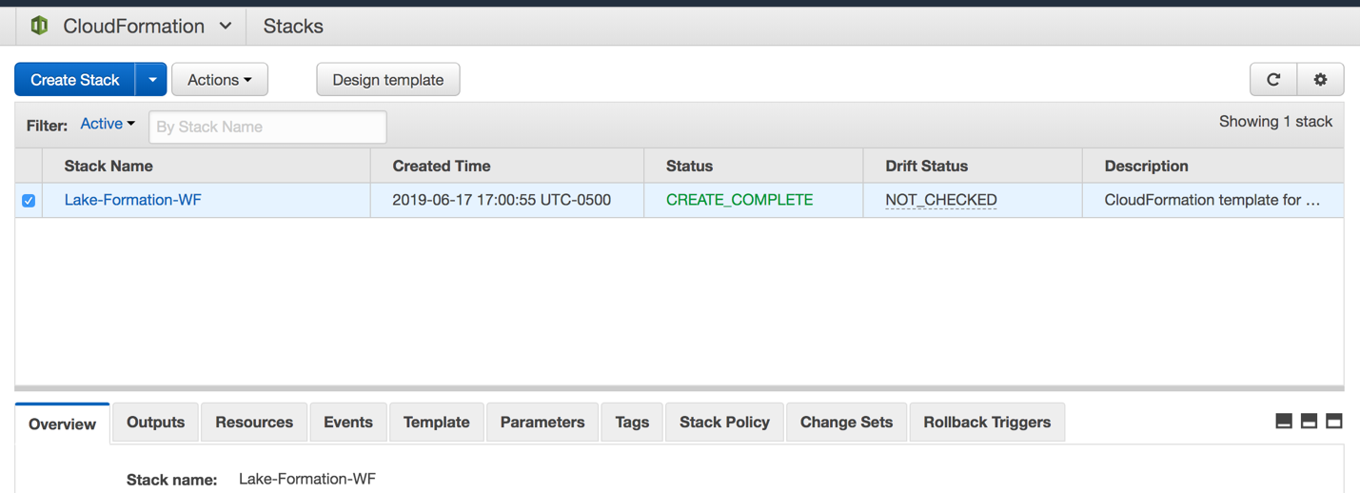](https://lakeformation.workshop.aws/images/cfn-complete.png)Once the stack creation is completed, your AWS account will have all required resources to run this workshop. Capture the data lake bucket name, password, and Athena query result output location from the output tab and proceed to the next chapter to run different lab.[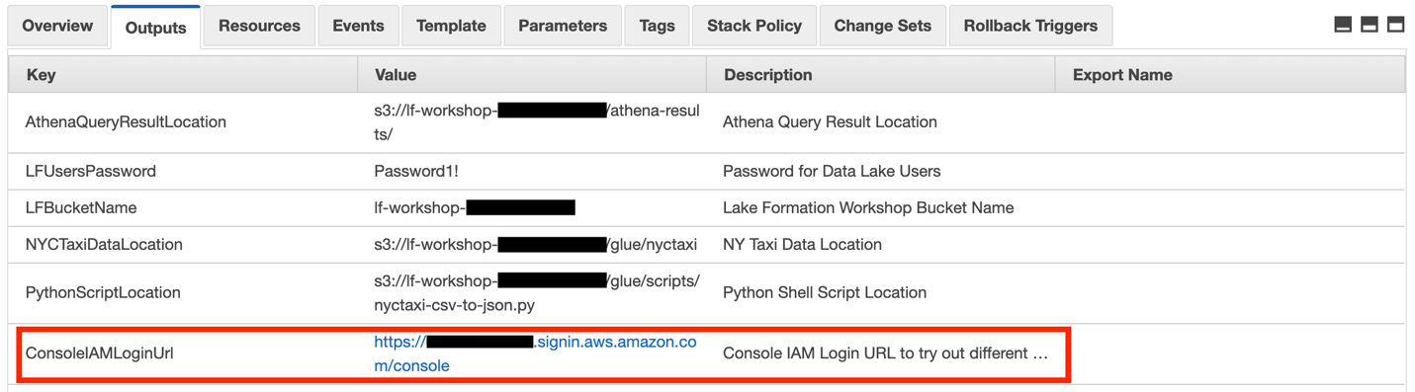](https://lakeformation.workshop.aws/images/cfn-complete-2.png)The CloudFormation template also shows AWS console IAM login link. Use that link to switch between different IAM users for this workshop.

GLUE DATA CATALOG

The AWS Glue Data Catalog is a managed service that lets you store, annotate, and share metadata in the AWS Cloud in the same way you would in an Apache Hive metastore. Each AWS account has one AWS Glue Data Catalog per AWS region. It provides a uniform repository where disparate systems can store and find metadata to keep track of data in data silos and use that metadata to query and transform the data.  
  
In addition, it has the following few extensions:

* Search - To search over metadata for data discovery
* Connection - To connect to different data sources for data discovery
* Classification - For identifying and parsing files
* Versioning - Versioning of table metadata as schemas evolve and other metadata are updated

Glue Crawler

You can use a crawler to populate the AWS Glue Data Catalog with tables. It automatically discover new data, extracts schema definitions. It detects schema changes and version tables. It can also detect Hive style partitions on Amazon S3.

Glue Connection

Connections are used by crawlers and jobs in AWS Glue to access certain types of data stores. A connection contains the properties that are needed to access your data store.

Glue Classifier

A classifier reads the data in a data store. If it recognizes the format of the data, it generates a schema. The classifier also returns a certainty number to indicate how certain the format recognition was. AWS Glue provides a set of built-in classifiers, but you can also create custom classifiers.  
  
The following diagram shows different connections and bulit-in classifiers which Glue offers.[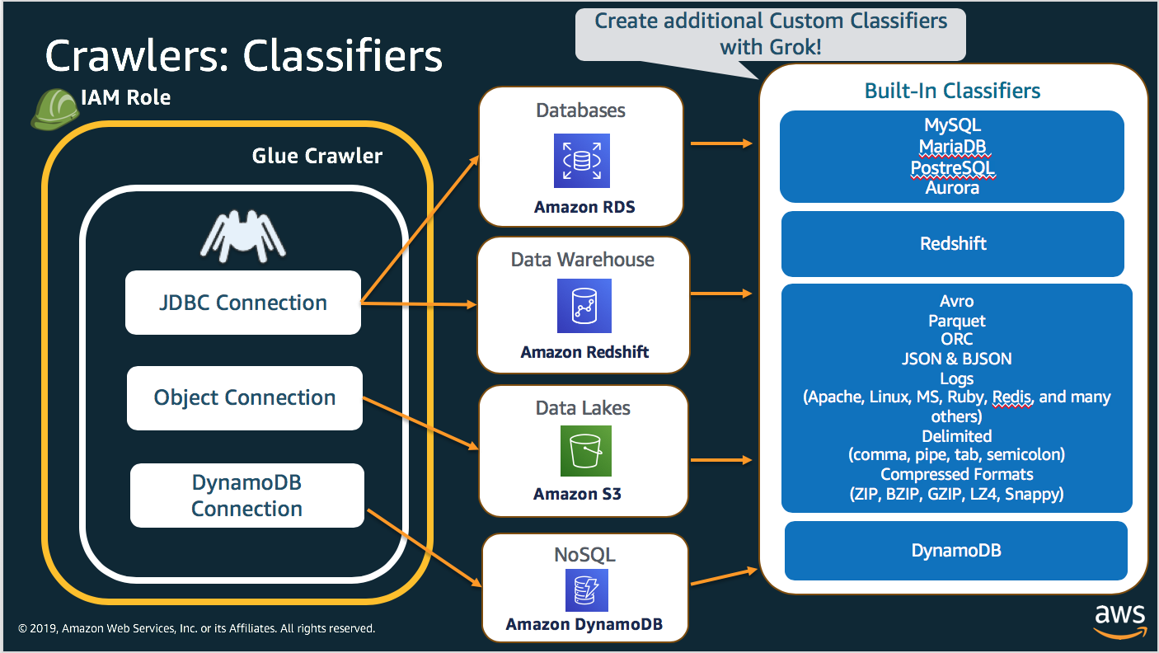](https://lakeformation.workshop.aws/images/glueconnectioncrawler.png)The following workflow diagram shows how AWS Glue crawlers interact with data stores and other elements to populate the Data Catalog.[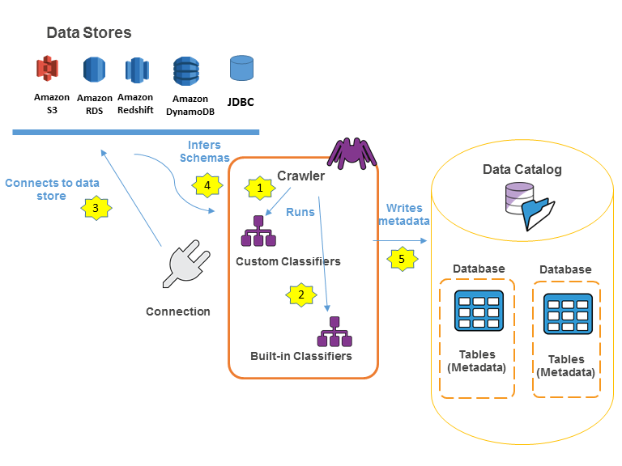](https://lakeformation.workshop.aws/images/PopulateCatalog-overview.png)The following is the general workflow for how a crawler populates the AWS Glue Data Catalog:

1. A crawler runs any custom classifiers that you choose to infer the format and schema of your data. You provide the code for custom classifiers, and they run in the order that you specify.
2. The first custom classifier to successfully recognize the structure of your data is used to create a schema. Custom classifiers lower in the list are skipped. If no custom classifier matches your data's schema, built-in classifiers try to recognize your data's schema. An example of a built-in classifier is one that recognizes JSON.
3. The crawler connects to the data store. Some data stores require connection properties for crawler access.
4. The inferred schema is created for your data.
5. The crawler writes metadata to the Data Catalog. A table definition contains metadata about the data in your data store. The table is written to a database, which is a container of tables in the Data Catalog. Attributes of a table include classification, which is a label created by the classifier that inferred the table schema.

In the next step, you will go through a few exercises to learn more about Glue Data Catalog components:

DATABASE

A database is used to organize tables in AWS Glue. When you define a table in the AWS Glue Data Catalog, you add it to a database.

1. Open the AWS Glue console at <https://console.aws.amazon.com/glue>.
2. Click on the Databases option on the left and then click on the Add database button.[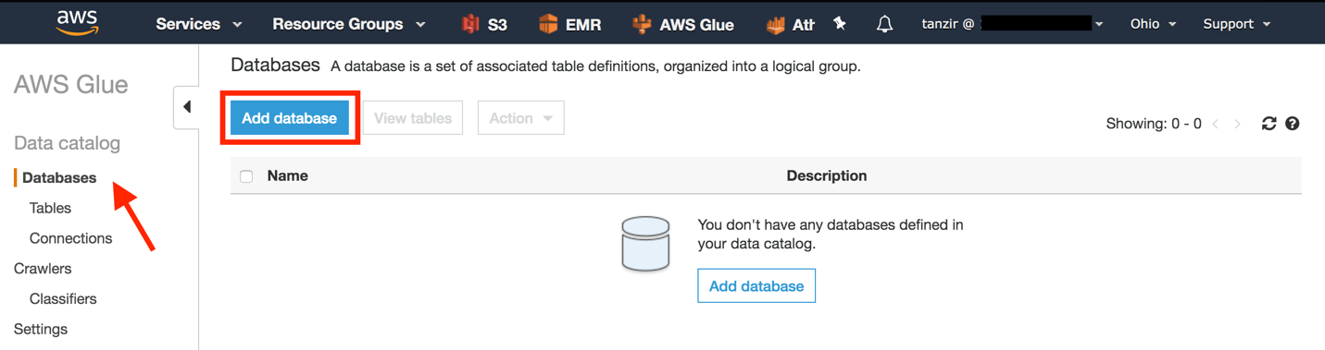](https://lakeformation.workshop.aws/images/gluedatabase1.png)
3. Type glue-demo in the Database name field and click Create.[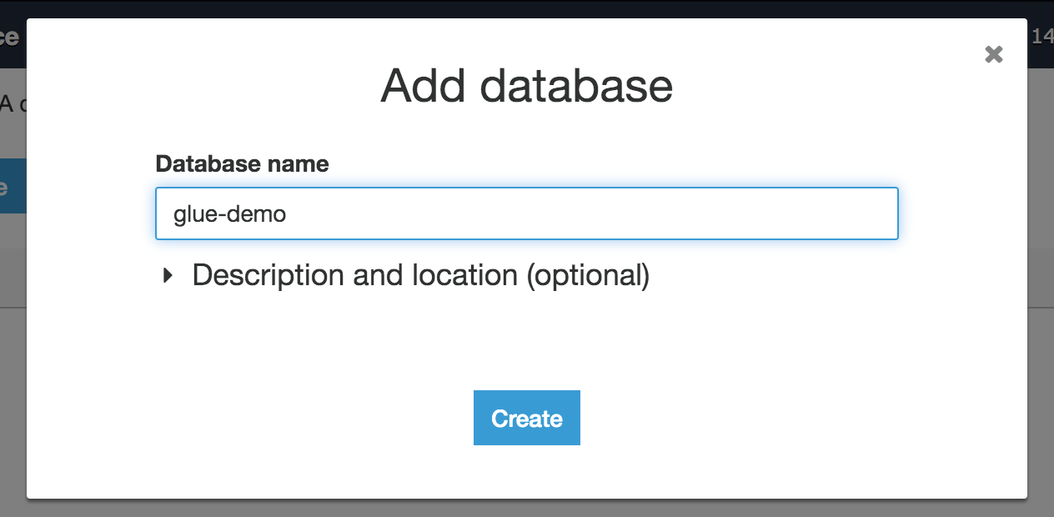](https://lakeformation.workshop.aws/images/gluedatabase2.png)
4. Verify the new database name in the database list and proceed to next exercise.

CONNECTION

The CloudFormation template in the Prerequisite section created a temporary database in RDS with TPC data. In this exercise, you will create a Glue Connection to connect to that RDS database.

1. Click on the Connections option on the left and then click on Add connection button.[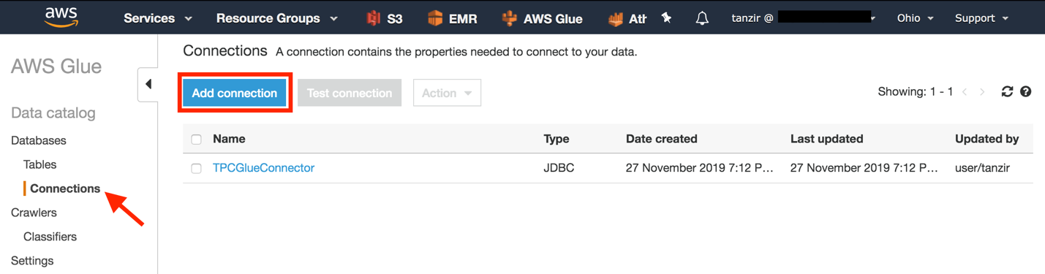](https://lakeformation.workshop.aws/images/glueconnection1.png)
2. In this section, you will provide connection details. Enter mysql-connector as the Connection Name, select Amazon RDS from the Connection type and MySQL as the Database engine, and click Next.[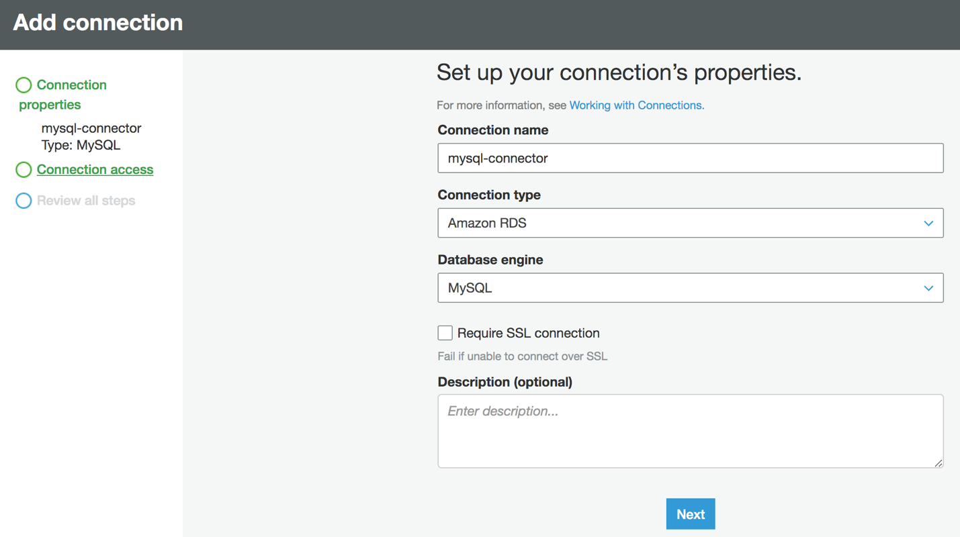](https://lakeformation.workshop.aws/images/glueconnection2.png)
3. You should be able to see tpc-database under instance, this is the RDS instance which was created by AWS CloudFormation template. When you select that database, Database name and Username fields will be populated automatically. Enter the database user password (default: BigData26!) in the Password field, and click Next.[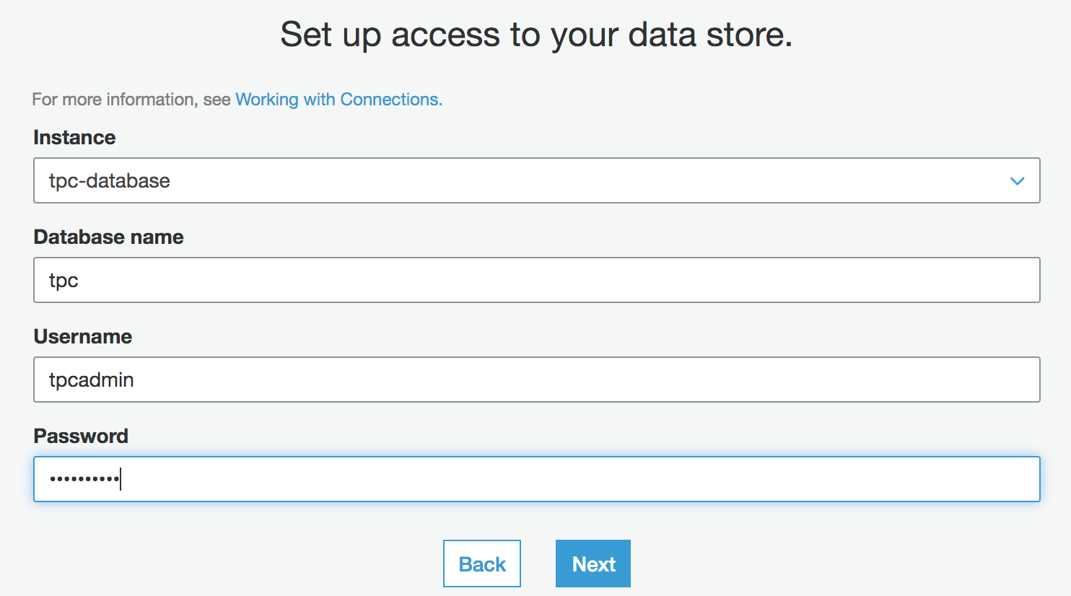](https://lakeformation.workshop.aws/images/glueconnection3.png)
4. Next window will show all connection information that you provided, verify that information, and click Finish.
5. Verify the newly created connection from the connection list, select that connect using the checkbox and click on Test connection to check the connection.[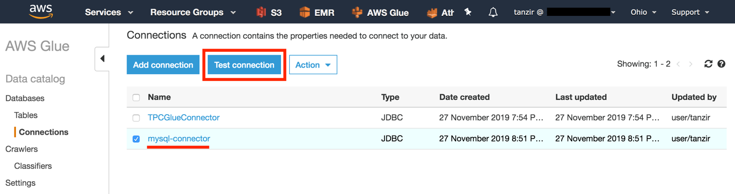](https://lakeformation.workshop.aws/images/glueconnection4.png)
6. Select IAM role LF-GlueServiceRole from the dropdown and click Test connection.[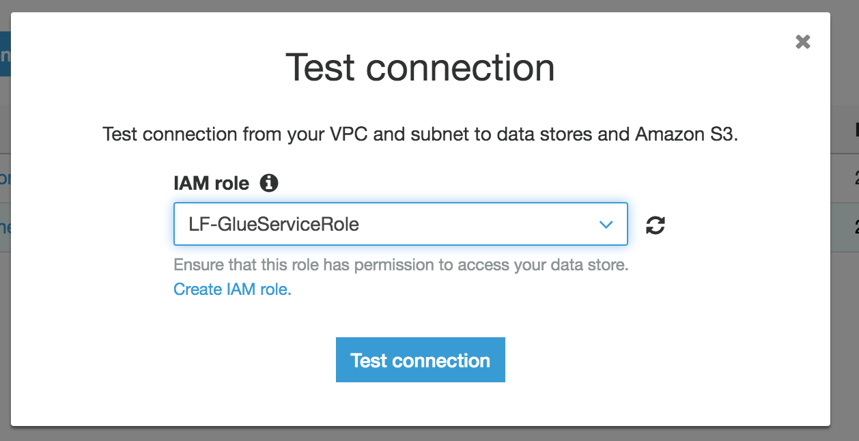](https://lakeformation.workshop.aws/images/glueconnection5.png)
7. If the connection is successful, a success message should be displayed. Proceed to the next chapter.[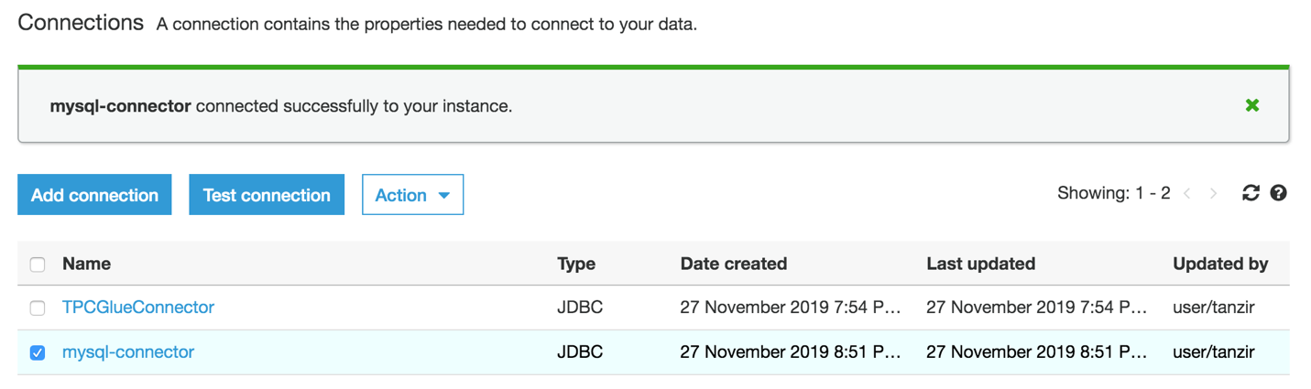](https://lakeformation.workshop.aws/images/glueconnection6.png)
8. In the next section, you will use this connection to create a JDBC crawler to discover schema in the TPC database.

# CRAWLING JDBC

Let's create a JDBC crawler using the connection you just created to extract the schema from the TPC database.

1. Click on the Crawlers option on the left and then click on the Add crawler button.[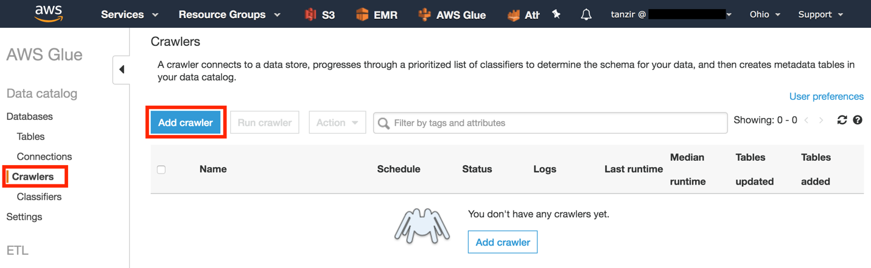](https://lakeformation.workshop.aws/images/gluecrawler1.png)
2. Enter tpc-crawler as the Crawler name and click Next.[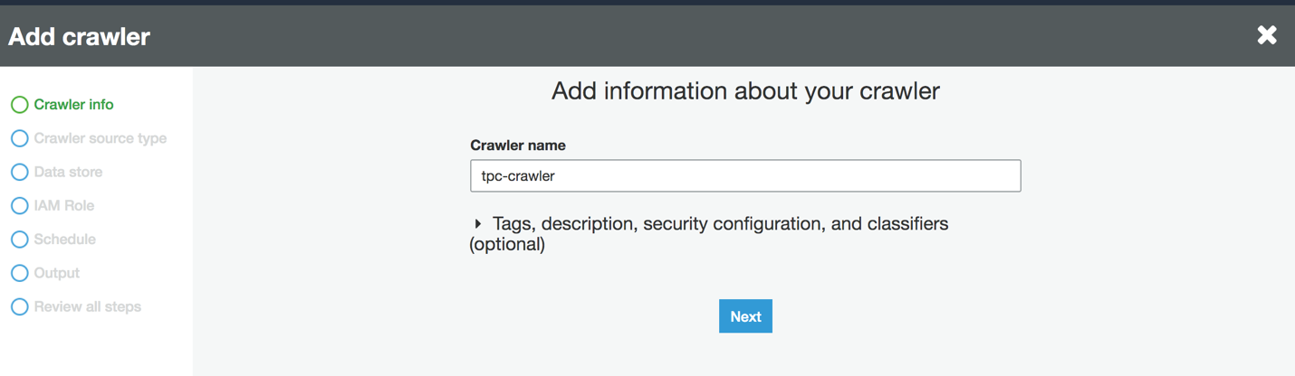](https://lakeformation.workshop.aws/images/gluecrawler2.png)
3. Select Data stores as the Crawler source type.[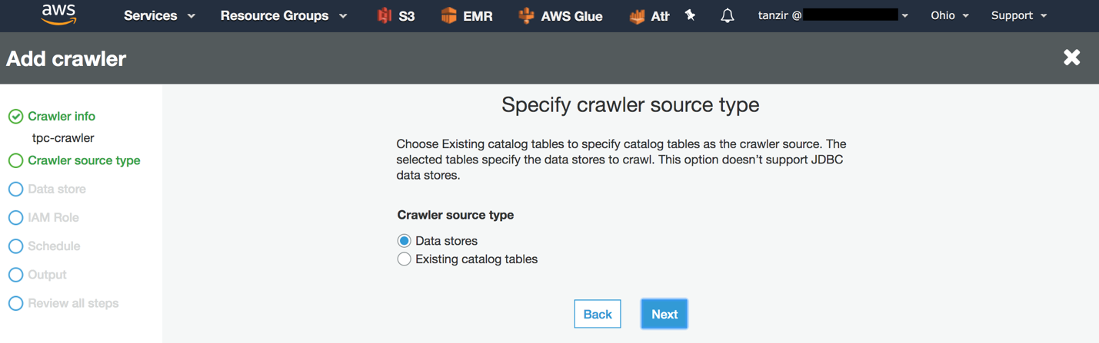](https://lakeformation.workshop.aws/images/gluecrawler3.png)
4. In this section you select the crawler type [S3, JDBC & DynamoDB]. Select JDBC as a data store, mysql-connector as the connection. You can crawl an entire schema/database or you can call any specific table or table with a prefix. For this exercise, we want to crawl just a single table. So, enter tpc/income_band in the Include path section. It will scan only the income_band table in the tpc schema.[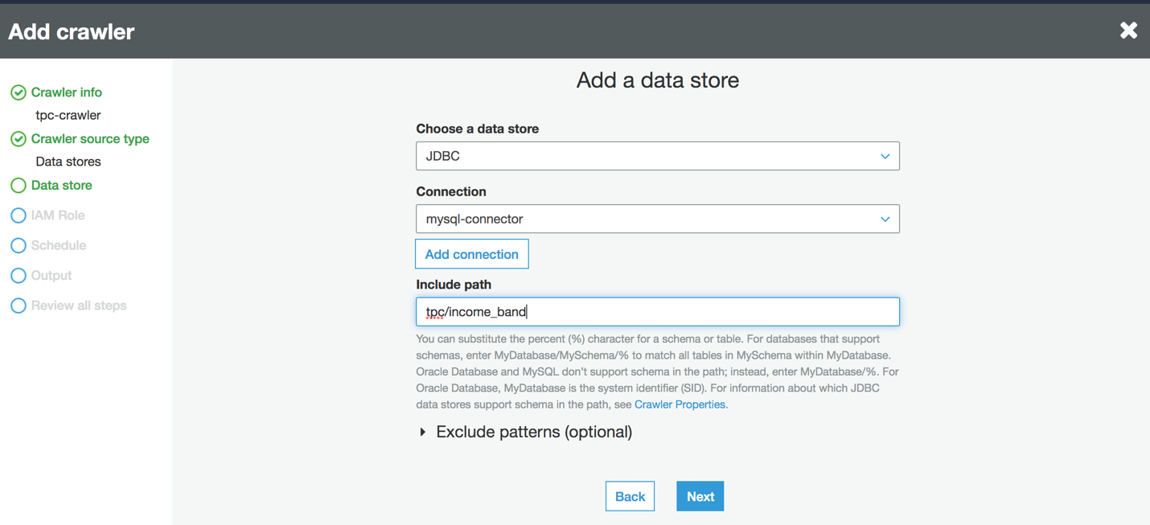](https://lakeformation.workshop.aws/images/gluecrawler4.png)
5. You are going to crawl only one data store, so select No from the option and click Next.[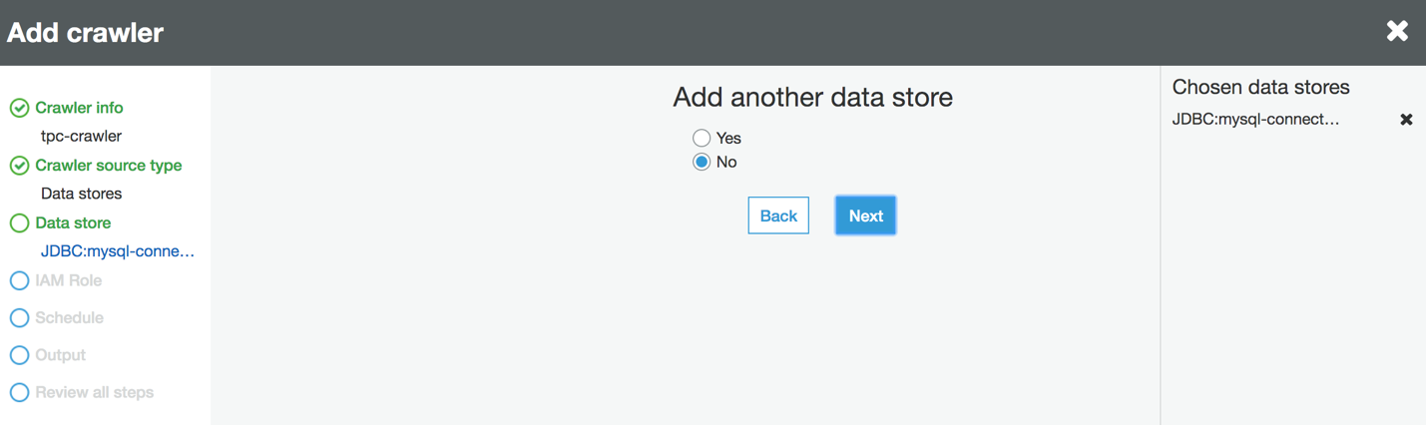](https://lakeformation.workshop.aws/images/gluecrawler5.png)
6. Select IAM role LF-GlueServiceRole from the dropdown list and proceed next.[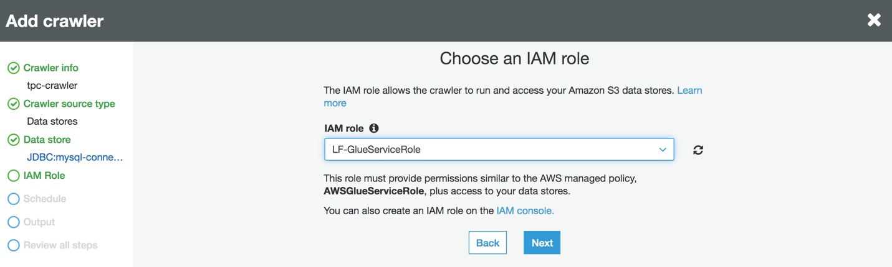](https://lakeformation.workshop.aws/images/gluecrawler6.png)
7. You can schedule a crawler in several ways but in this exercise, you run it on demand. Select Run on demand and move next.
8. In this step, you decide where to store the crawler's output. We want to update the database created in this exercise. Select glue-demo from the database list and enter jdbc_ as a prefix. Leave the rest of the options as default and move next.[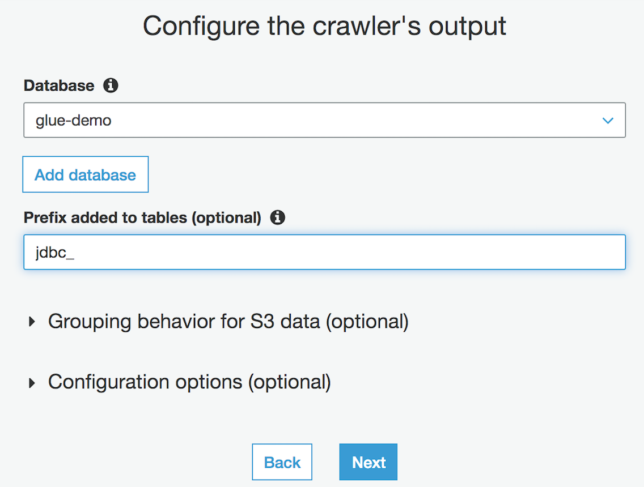](https://lakeformation.workshop.aws/images/gluecrawler7.png)
9. Verify all crawler information on the screen and click Finish to create the crawler.
10. When the crawler is newly created, it will ask you if you want to run it now. Click on Run it now link. Alternatively, you can select the crawler and run the crawler from the Action.[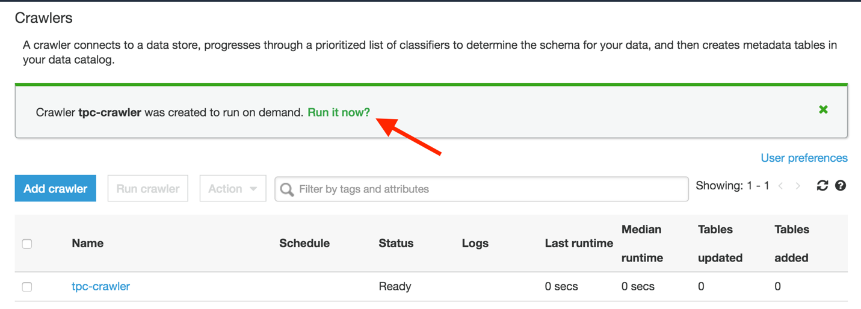](https://lakeformation.workshop.aws/images/gluecrawler8.png)
11. It may take up to 2 minutes for the crawler to finish crawling income_band table. You should be able to see a success message with the table count that got discovered through the crawler.[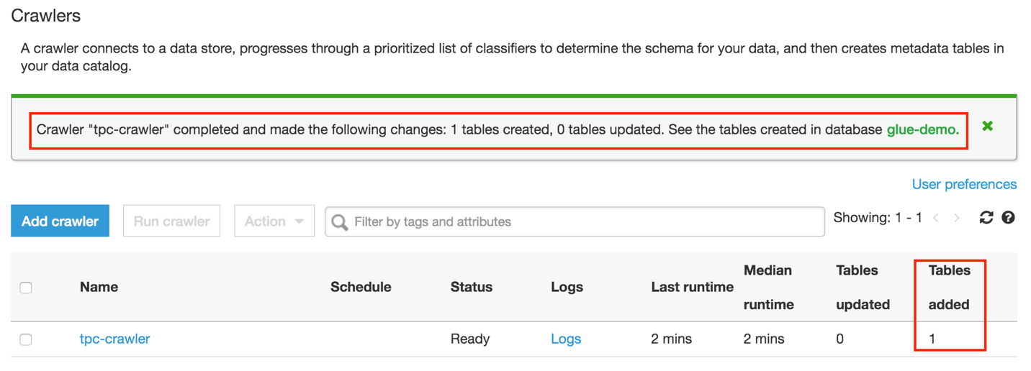](https://lakeformation.workshop.aws/images/gluecrawler9.png)
12. Now go back to Databases -> Tables, you should be able to see the table jdbc_tpc_income_band. Click on it.[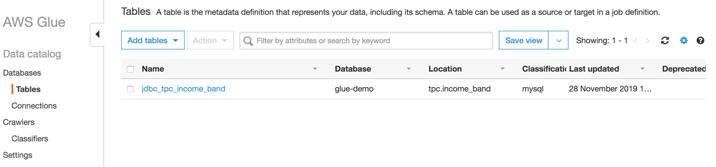](https://lakeformation.workshop.aws/images/gluecrawler10.png)
13. Clicking on the table, it will display table metadata, inferred schema and it's properties. If the table had partitions or multiple versions, it would display here. By looking at the table properties, you will discover the schema and know more about the source.[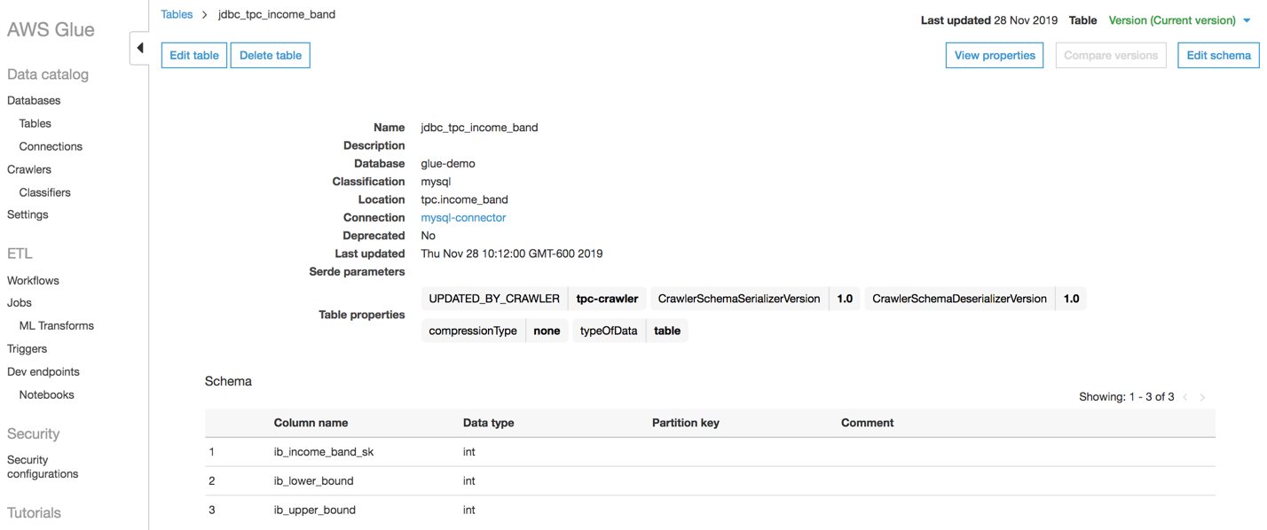](https://lakeformation.workshop.aws/images/gluecrawler11.png)
14. Proceed to the next exercise, where you will run the crawler again but this time it will crawl a file on S3 location to discover it's the schema.

# CRAWLING S3

In this exercise, you will create one more crawler but this time, the crawler will discover schema from a file stored in S3.

1. Click on the Crawlers option on the left and then click on Add crawler button.[](https://lakeformation.workshop.aws/images/gluecrawler1.png)
2. Enter nyctaxi-crawler as the Crawler name and click Next.[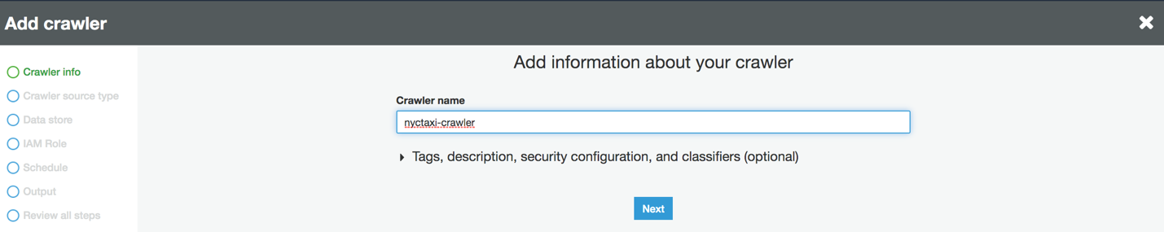](https://lakeformation.workshop.aws/images/gluecrawler12.png)
3. Select Data stores as the Crawler source type.[](https://lakeformation.workshop.aws/images/gluecrawler3.png)
4. Select S3 as a data store and provide the input path which contains tripdata.csv file (s3://lf-workshop-<account-id>/glue/nyctaxi).[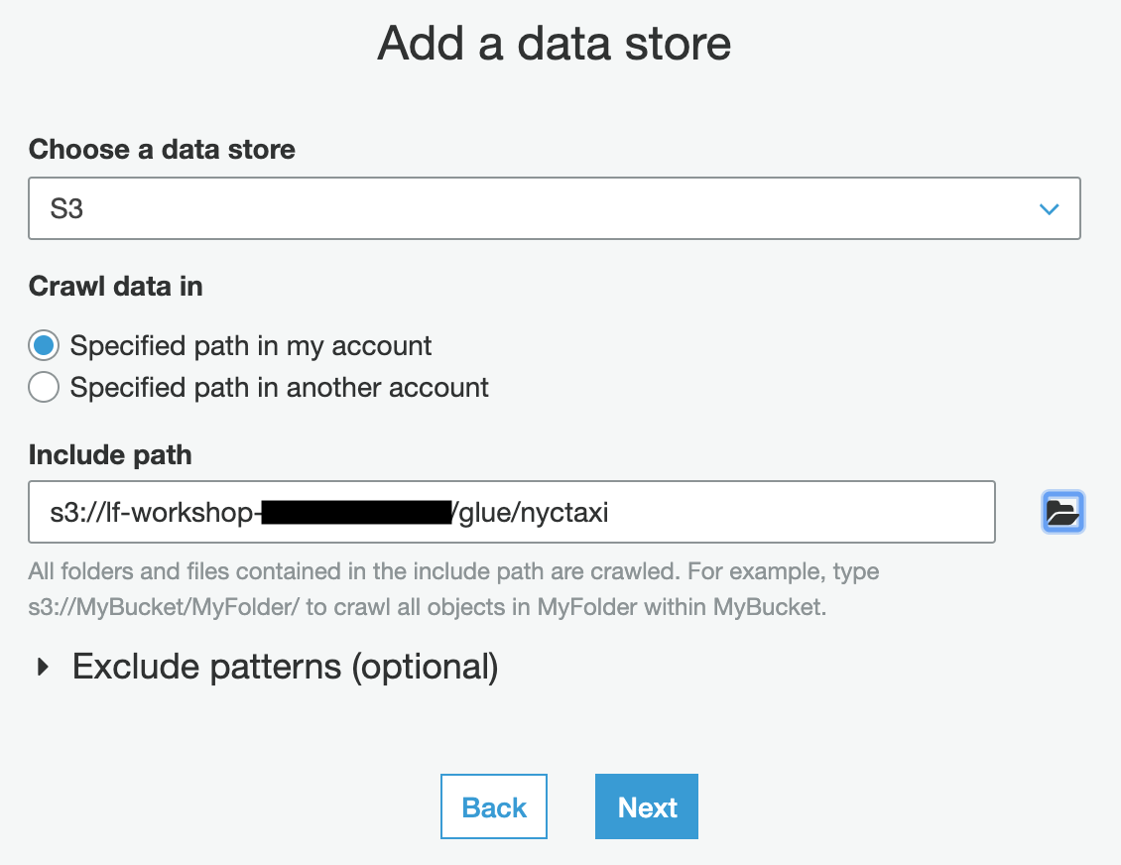](https://lakeformation.workshop.aws/images/gluecrawler13.png)
5. You are going to crawl only one data store, so select No from the option and click Next.[](https://lakeformation.workshop.aws/images/gluecrawler5.png)
6. Select IAM role LF-GlueServiceRole from the dropdown list, this IAM role should have access to the S3 file you want to crawl.[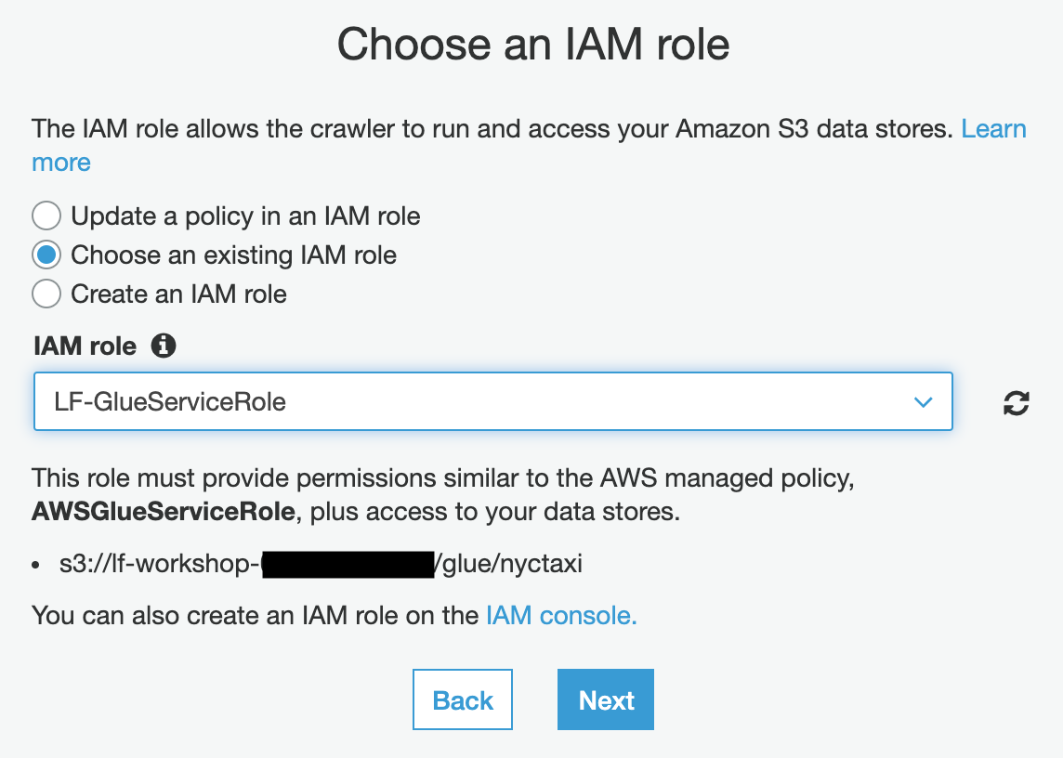](https://lakeformation.workshop.aws/images/gluecrawler17.png)
7. Like the last exercise, you will execute this command on demand. Select Run on demand and move next.
8. You are going to populate this crawler output to the same database glue-demo. Enter s3_ as a prefix. Leave the rest of the options as default and move next.[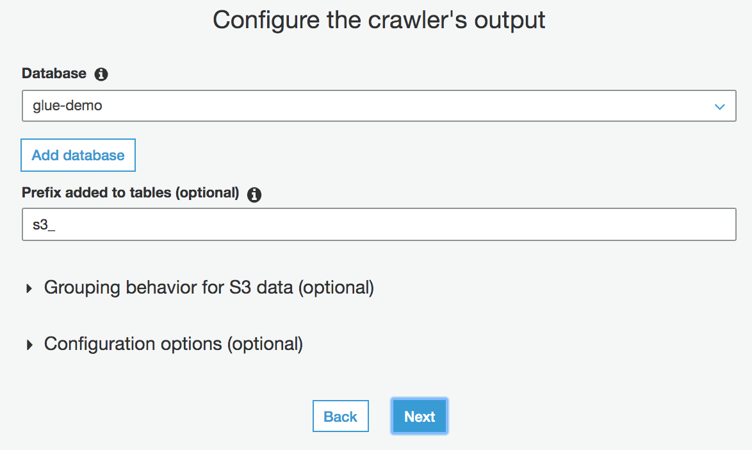](https://lakeformation.workshop.aws/images/gluecrawler18.png)
9. Verify all crawler information on the screen and click Finish to create the crawler.
10. Click on Run it now link. Alternatively, you can select the crawler and run the crawler from the Action.[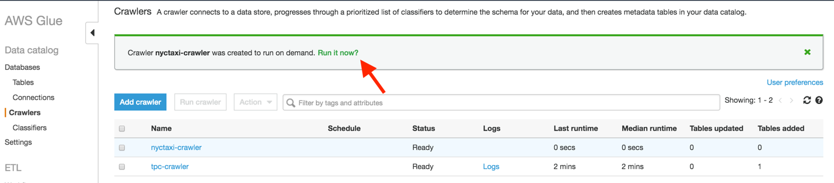](https://lakeformation.workshop.aws/images/gluecrawler15.png)
11. It may take up to 2 minutes for the crawler to finish crawling nyctaxi.csv file. You should be able to see a success message with the table count that got discovered through this crawler.[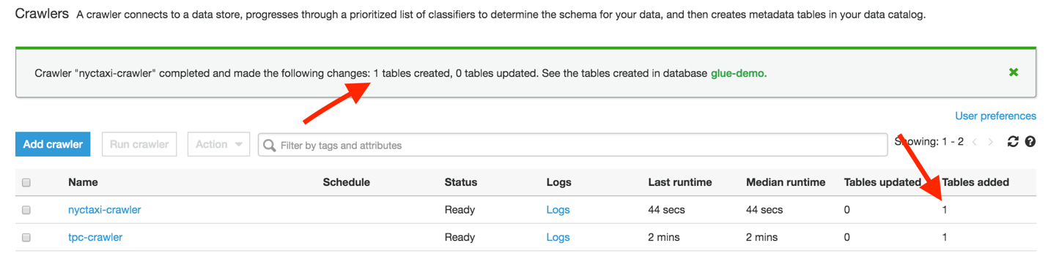](https://lakeformation.workshop.aws/images/gluecrawler16.png)
12. Now go back to Databases -> Tables, you should be able to see the table s3_nyctaxi. Click on it.[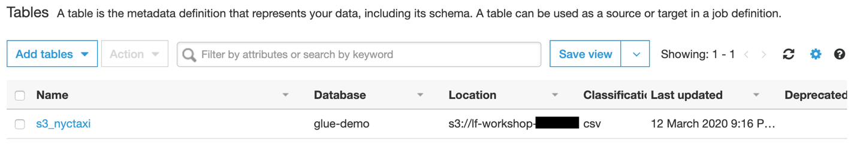](https://lakeformation.workshop.aws/images/gluecrawler19.png)
13. Clicking on the table, it will display table metadata, inferred schema and it's properties. If the table had partitions or multiple versions, it would display here. By looking at the table properties, you will discover the schema and know more about the source.[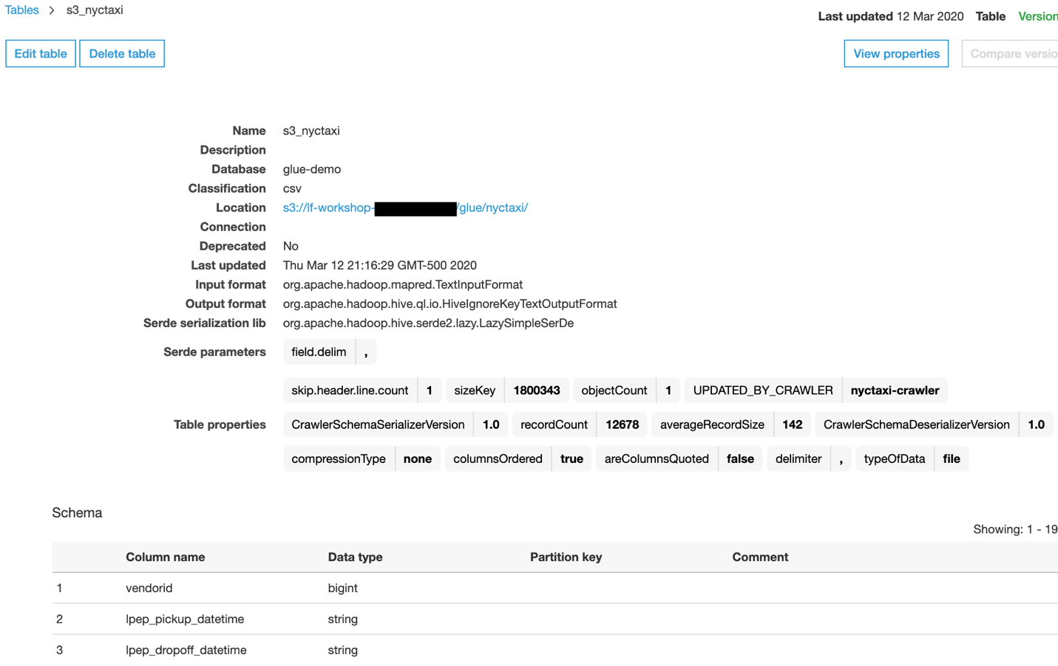](https://lakeformation.workshop.aws/images/gluecrawler20.png)
14. By running these two crawlers, you should get an understanding of how Crawler works and how you can use Glue Crawler to discover schema coming from different sources.

# GLUE ETL

AWS Glue provides a console and API operations to set up and manage your extract, transform, and load (ETL) workload. You can use API operations through several language-specific SDKs and the AWS Command Line Interface (AWS CLI).  
  
Using the metadata in the Data Catalog, AWS Glue can autogenerate Scala or PySpark (the Python API for Apache Spark) scripts with AWS Glue extensions that you can use and modify to perform various ETL operations. For example, you can extract, clean, and transform raw data, and then store the result in a different repository, where it can be queried and analyzed.  
  
A job is the business logic that performs the extract, transform, and load (ETL) work in AWS Glue. When you start a job, AWS Glue runs a script that extracts data from sources, transforms the data, and loads it into targets. You can create jobs in the ETL section of the AWS Glue console.  
  
The following diagram summarizes the basic workflow and steps involved in authoring a job in AWS Glue:

[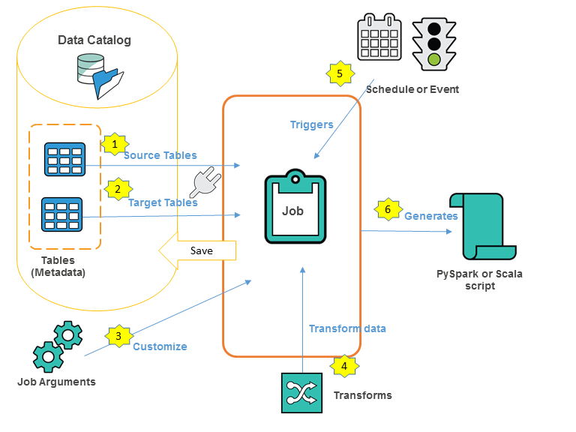](https://lakeformation.workshop.aws/images/AuthorJob-overview.png)

The following describes an overall process of authoring jobs in the AWS Glue console:

1. You choose a data source for your job. The tables that represent your data source must already be defined in your Data Catalog. If the source requires a connection, the connection is also referenced in your job. If your job requires multiple data sources, you can add them later by editing the script.
2. You choose a data target for your job. The tables that represent the data target can be defined in your Data Catalog, or your job can create the target tables when it runs. You choose a target location when you author the job. If the target requires a connection, the connection is also referenced in your job. If your job requires multiple data targets, you can add them later by editing the script.
3. You customize the job-processing environment by providing arguments for your job and generated script.
4. Initially, AWS Glue generates a script, but you can also edit this script to add sources, targets, and transforms.
5. You specify how your job is invoked, either on-demand, by a time-based schedule, or by an event.
6. Based on your input, AWS Glue generates a PySpark or Scala script. You can tailor the script based on your business needs.

In the next step, you will go through a few exercises to learn more about different Glue ETL approaches.

# SPARK JOBS

An Apache Spark ETL job consists of the business logic that performs ETL work in AWS Glue. You can monitor job runs to understand runtime metrics such as success, duration, and start time. The output of a job is your transformed data, written to a location that you specify.  
  
In the previous step, you crawled S3 .csv file and discovered the schema of NYC taxi data. In this exercise, you will create a Spark job in Glue, which will read that source, write them to S3 in Parquet format.

1. Click on the Jobs option on the left and then click on Add job button.[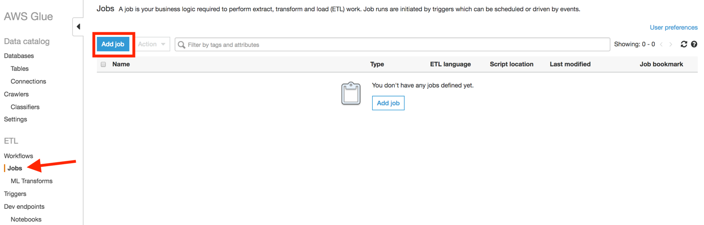](https://lakeformation.workshop.aws/images/gluejob1.png)
2. Give a name for your job nyctaxi-csv-to-parquet, select IAM role LF-GlueServiceRole from the IAM role drop-down list. Since you are creating Spark ETL job, so leave the rest of the fields as default and move to the field where it asks you where to store your script and temporary directory. The CloudFormation template created the required bucket, here you enter the path for the script location s3://lf-workshop-<account-id>/glue/scripts and temporary directory s3://lf-workshop-<account-id>/glue/temp and proceed to the next window.[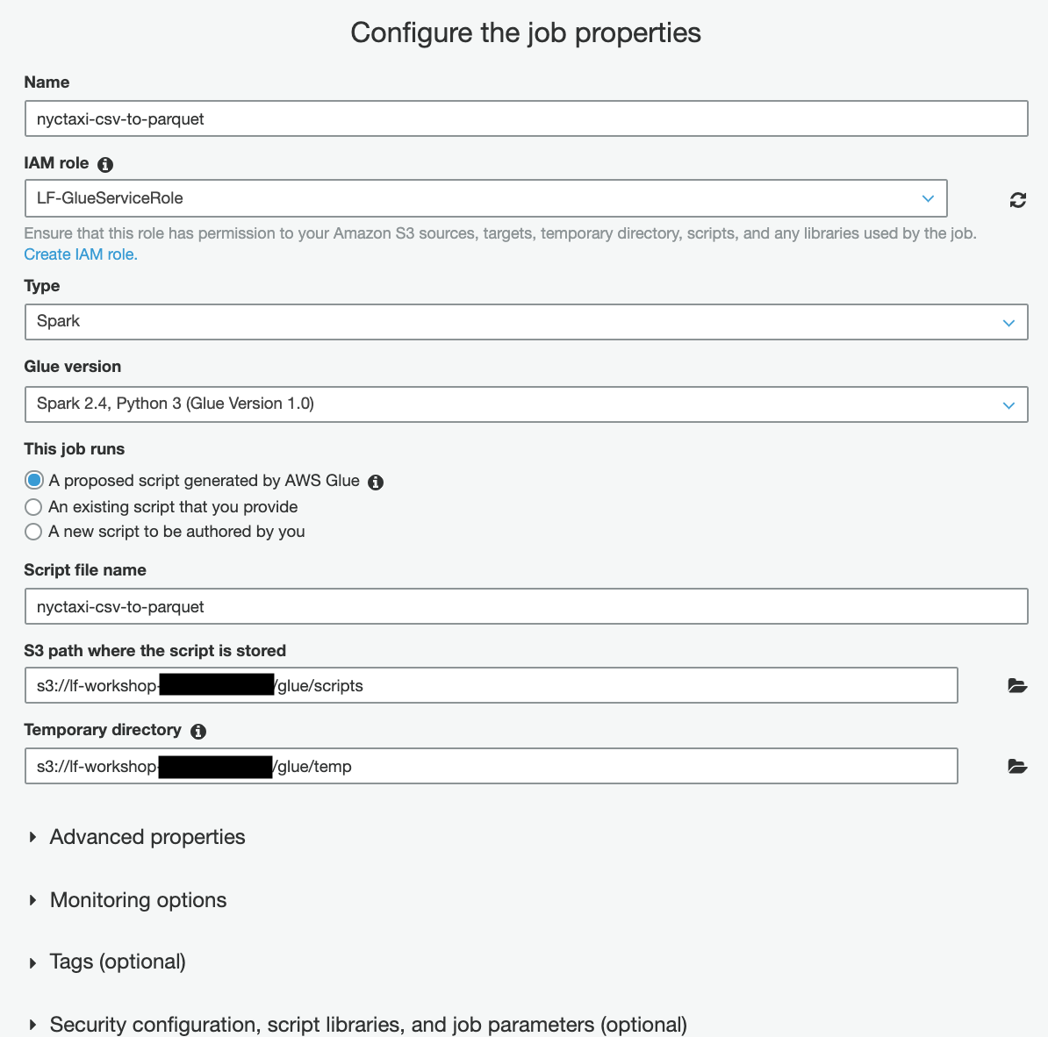](https://lakeformation.workshop.aws/images/gluejob2.png)
3. In this section, you define your source. For you, the source is the s3_nyctaxi as you are going to transform that source to Parquet. Select s3_nyctaxi as the source.[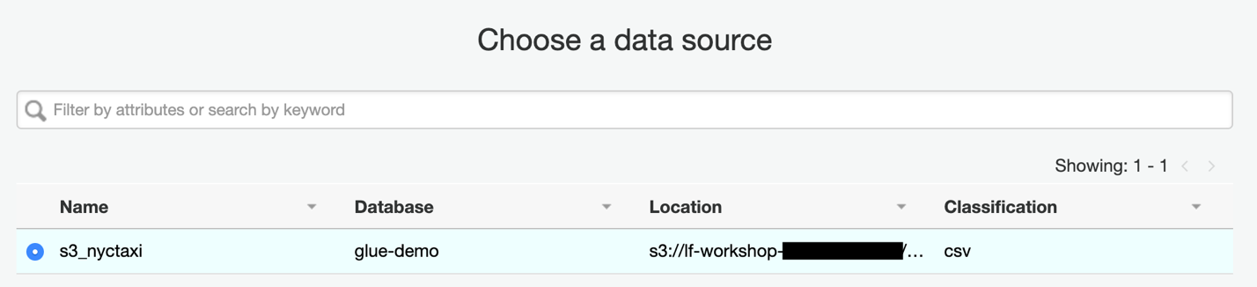](https://lakeformation.workshop.aws/images/gluejob3.png)
4. Here you are transforming your source to a different dataset. You can also find matching records using ML transforms. Select Change schema and proceed next.

[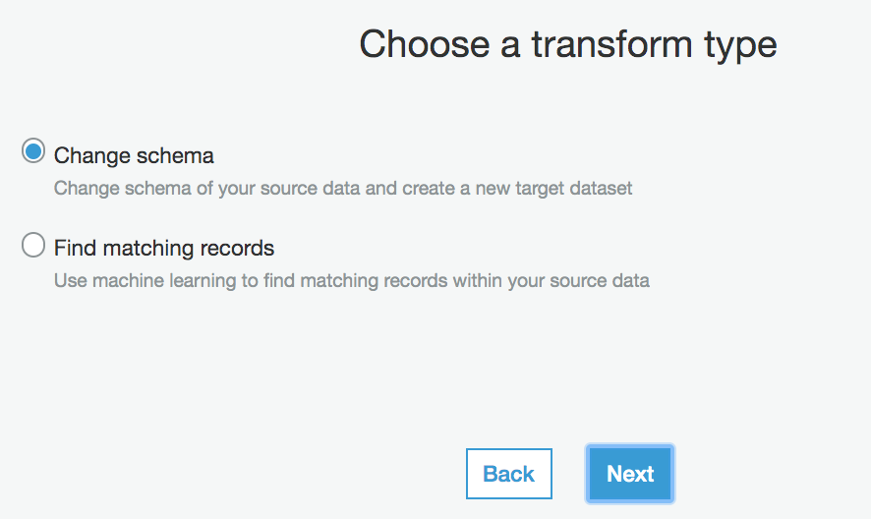](https://lakeformation.workshop.aws/images/gluejob4.png)

1. You have multiple options for target, you can update already existing catalog/table or you can create a new target. For this exercise, you are going to write into S3 in Parquet format. Enter values based on that, using the same bucket that got created for this Glue exercise.[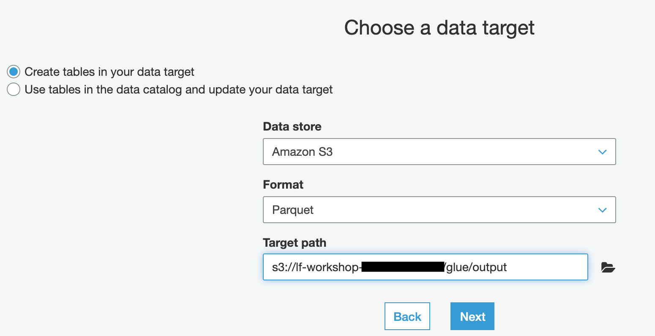](https://lakeformation.workshop.aws/images/gluejob5.png)
2. Glue automatically detects mapping between source and target. You can change the mapping based on your requirement, eg.g. change column names, drop, add or merge columns. For this exercise, leave the mappings as it is and click on Save job and edit script.[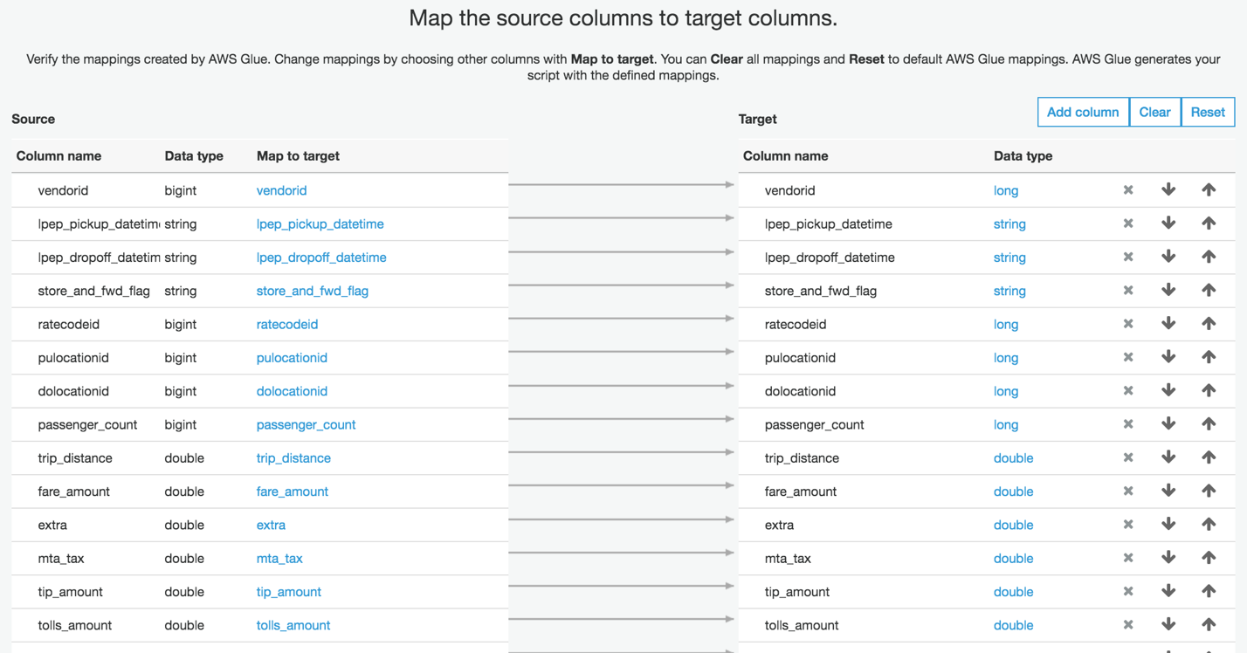](https://lakeformation.workshop.aws/images/gluejob6.png)
3. Glue will generate the script based on your configuration. You have full authority to your script, you can add additional business logic, modify source or target, change mappings. Once you satisfy with your script, you run it by clicking on the Run job button.[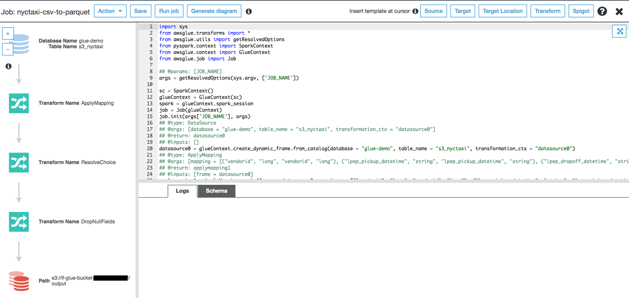](https://lakeformation.workshop.aws/images/gluejob7.png)
4. Clicking on the Run job should open up this window. Here, you provide additional configurations for the job. You can pass Tags, update different monitoring options, provide library path or configure worker type and resource size. For this exercise, leave all options as default and click on Run job button.

[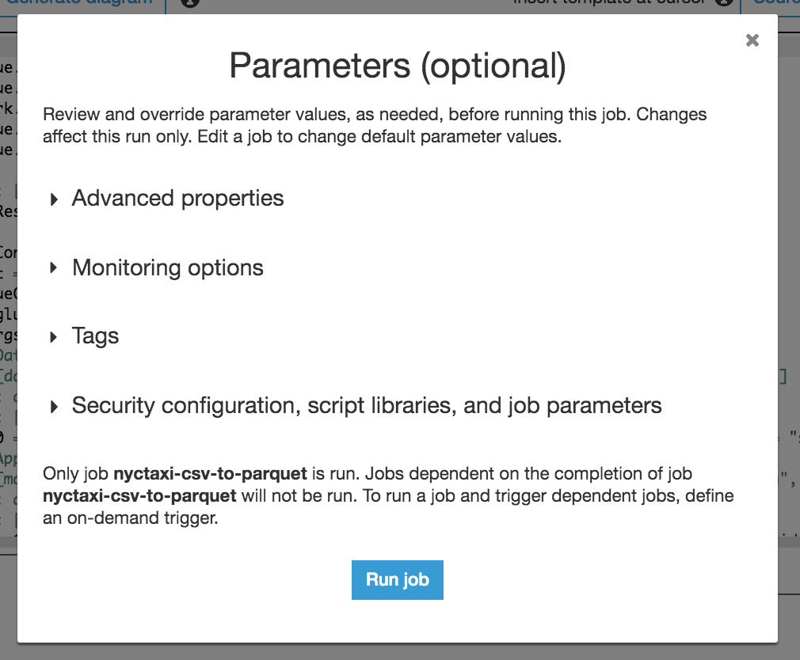](https://lakeformation.workshop.aws/images/gluejob8.png)

1. When the job is running, you will notice that the Run job button is grayed out with a circular-spinner icon.[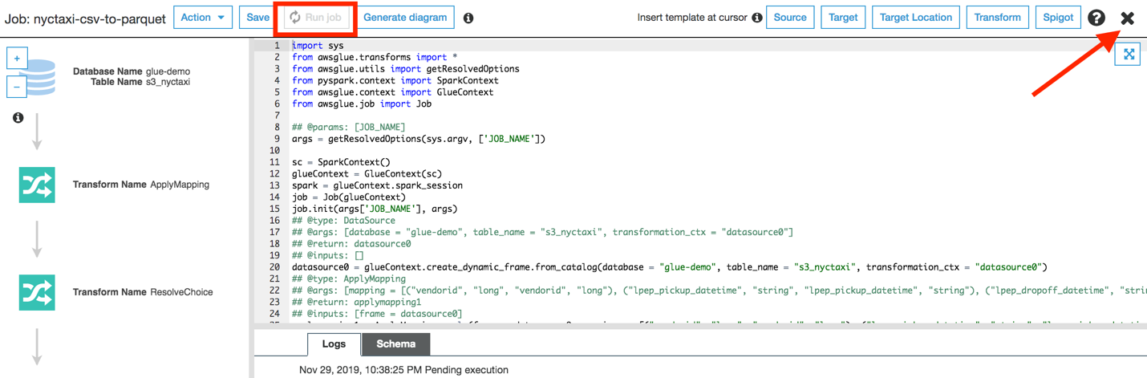](https://lakeformation.workshop.aws/images/gluejob9.png)
2. Exit from the script window. You can monitor additional job metrics by going back to the Glue job console and select the individual job. Metrics tab displays job metrics, the History tab shows job history.[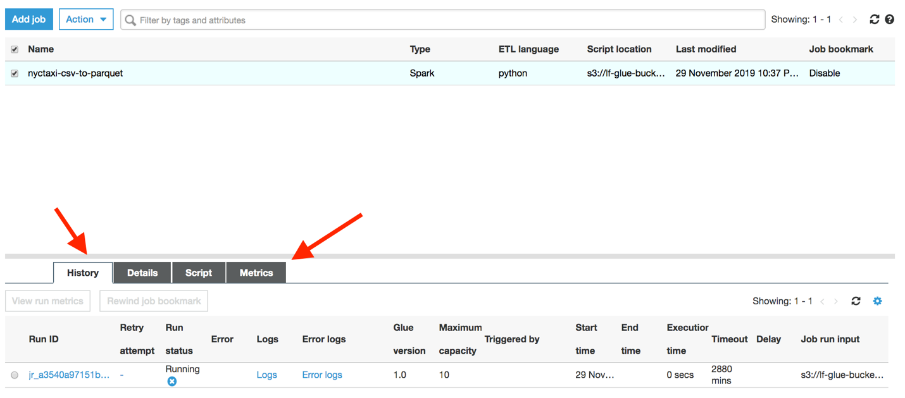](https://lakeformation.workshop.aws/images/gluejob10.png)
3. Run status column shows job status, this Spark job may take from 2 to 12 minutes. Once the job is completed successfully, it will show up Succeed status.[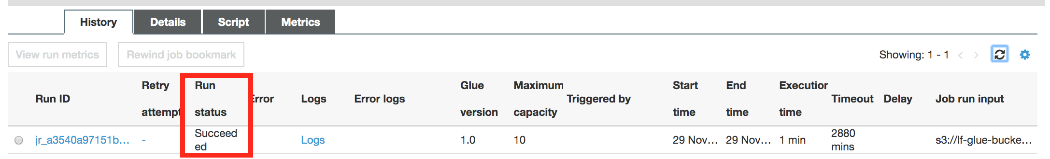](https://lakeformation.workshop.aws/images/gluejob11.png)
4. If the job is finished successfully, it should have created Parquet output in the target location selected in Step 5. Open up the S3 console and check the target location. The location should be populated with Parquet files as displayed below.[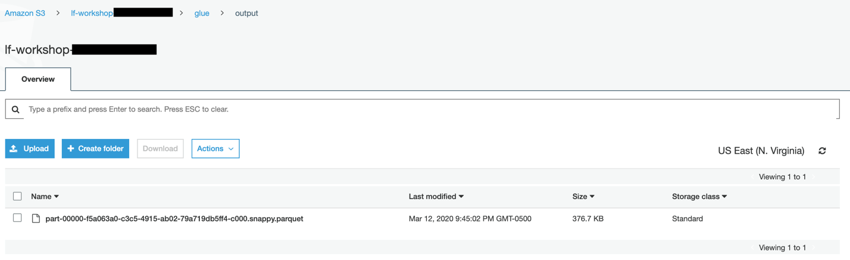](https://lakeformation.workshop.aws/images/gluejob12.png)
5. You learn how Glue auto-generates PySpark script for you depending on your ETL job. It can also generate Scala codes by following the same steps. In the next exercise, you will learn how you can run Python-based jobs using the Glue Python shell.

# PYTHON SHELL

You can also use a Python shell job to run Python scripts as a shell in AWS Glue. With a Python shell job, you can run scripts that are compatible with Python 2.7 or Python 3.6. The environment for running a Python shell job supports libraries such as: Boto3, collections, CSV, gzip, multiprocessing, NumPy, pandas, pickle, PyGreSQL, re, SciPy, sklearn, xml.etree.ElementTree, zipfile.  
  
In the previous exercise, you used PySpark to transform NYC Taxi .csv data to Parquet. In this exercise, you will use Panda through Python Shell to covert the same input data to JSON.

1. Click on the Jobs option on the left and then click on Add job button.[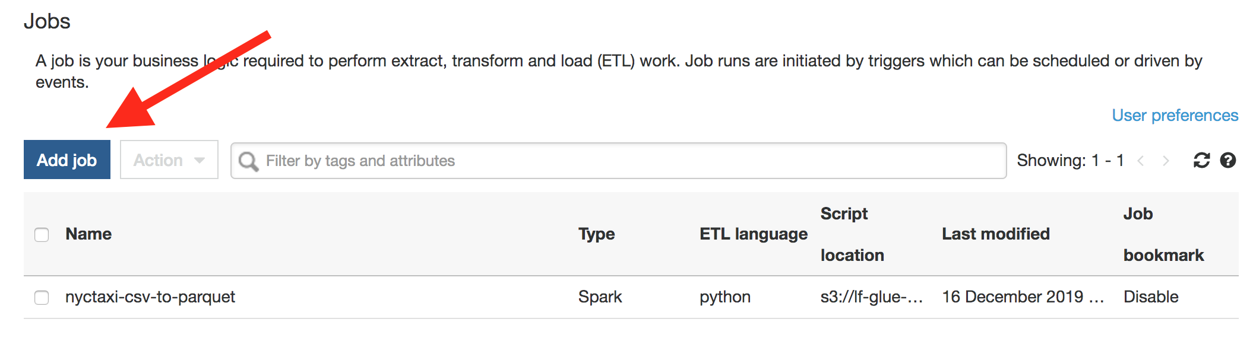](https://lakeformation.workshop.aws/images/pythonjob1.png)
2. Give a name for your Python Shell job nyctaxi-csv-to-json, select IAM role LF-GlueServiceRole from the IAM role drop-down list. Select Python Shell as your job type. The CloudFormation template already placed a Python script in your workshop bucket and showed the location as the CloudFormation output. Enter the Python script path as shown below:[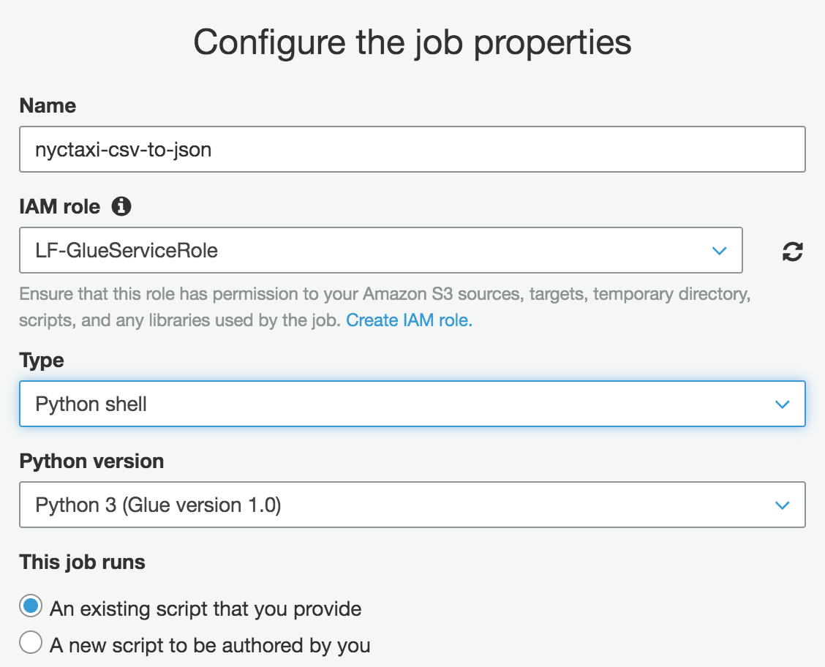](https://lakeformation.workshop.aws/images/pythonjob2.png)[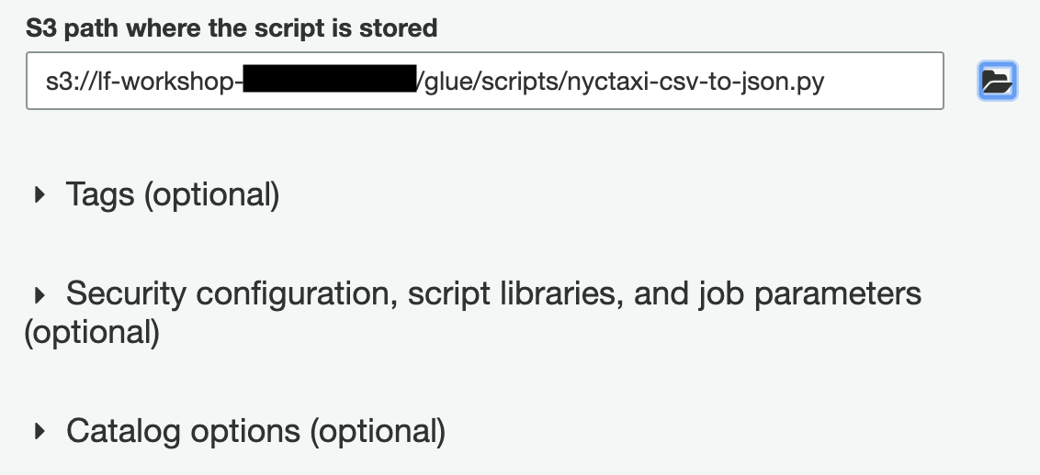](https://lakeformation.workshop.aws/images/pythonjob3.png)
3. Leave the rest of the fields as it is and click Next. In the next section, it shows the connection options. If you want to use any existing Glue Connection in your script, you can do that as well. But, for this exercise, it doesn't use Glue Connection. Click Save job and edit script.
4. It will open up the existing Python script on the Glue console. The script has one input parameter which is the name of the bucket. The key for the parameter is --bucket.[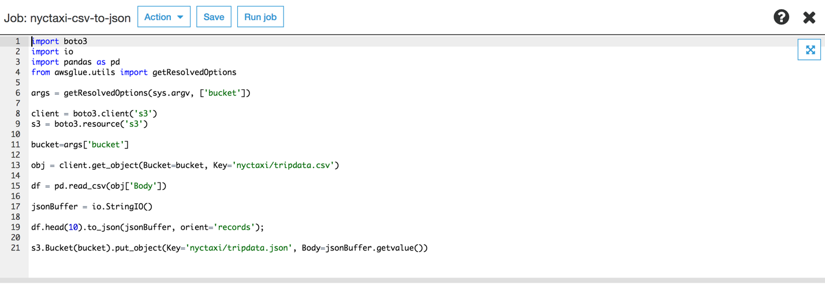](https://lakeformation.workshop.aws/images/pythonjob4.png)
5. Click Run job and expand the second toggle where it says job parameter.[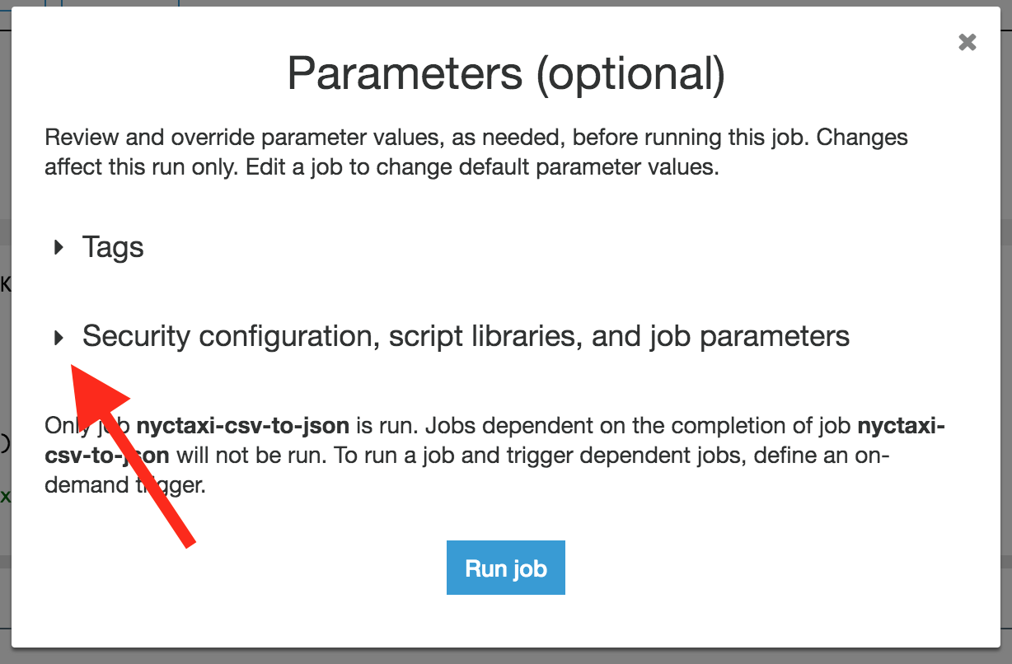](https://lakeformation.workshop.aws/images/pythonjob5.png)
6. Go to the Job parameters section and enter --bucket as your key and bucket name (from the CloudFormation output) as the value and click Run job.[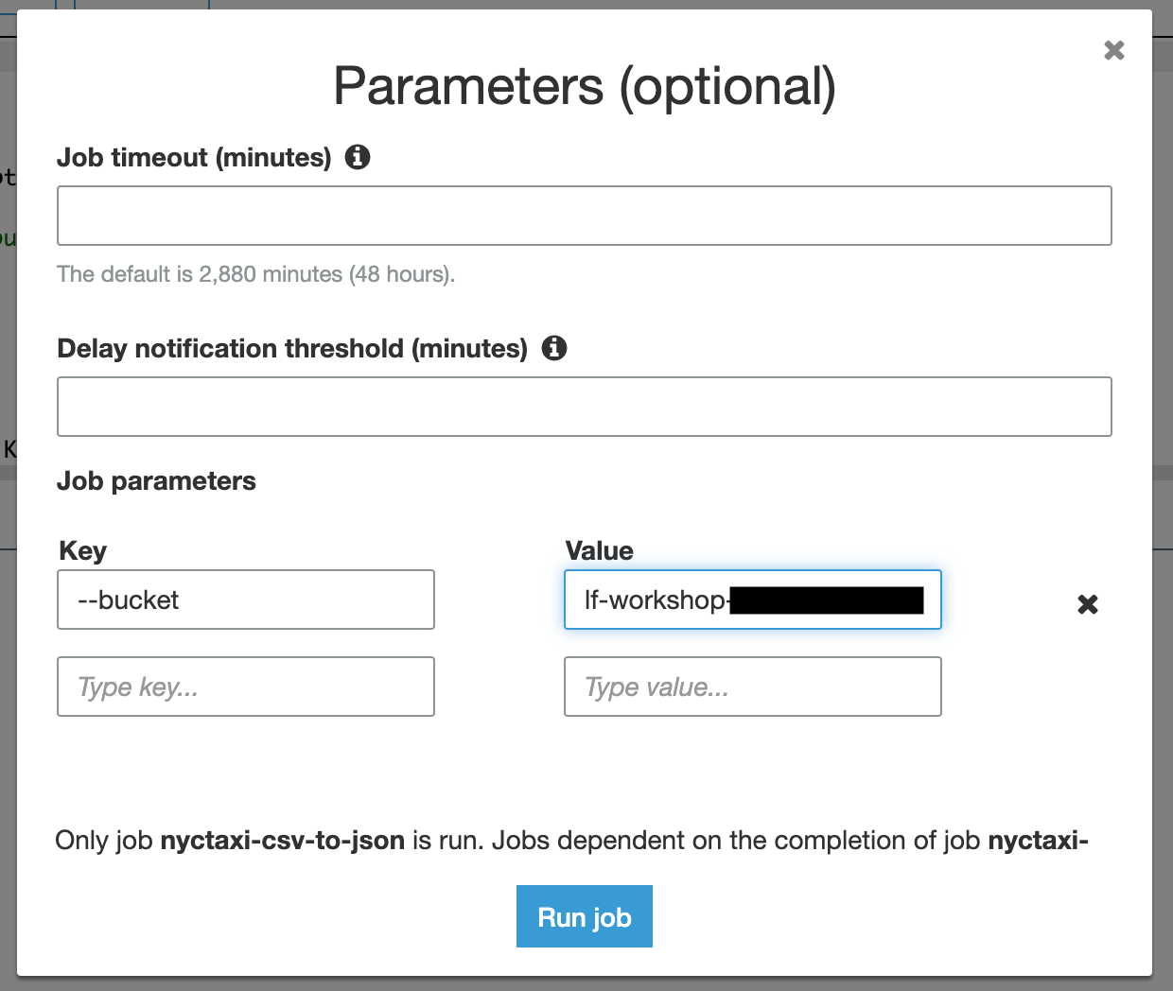](https://lakeformation.workshop.aws/images/pythonjob6.png)
7. You can exit from the script window and check the job status by selecting the job from the list.[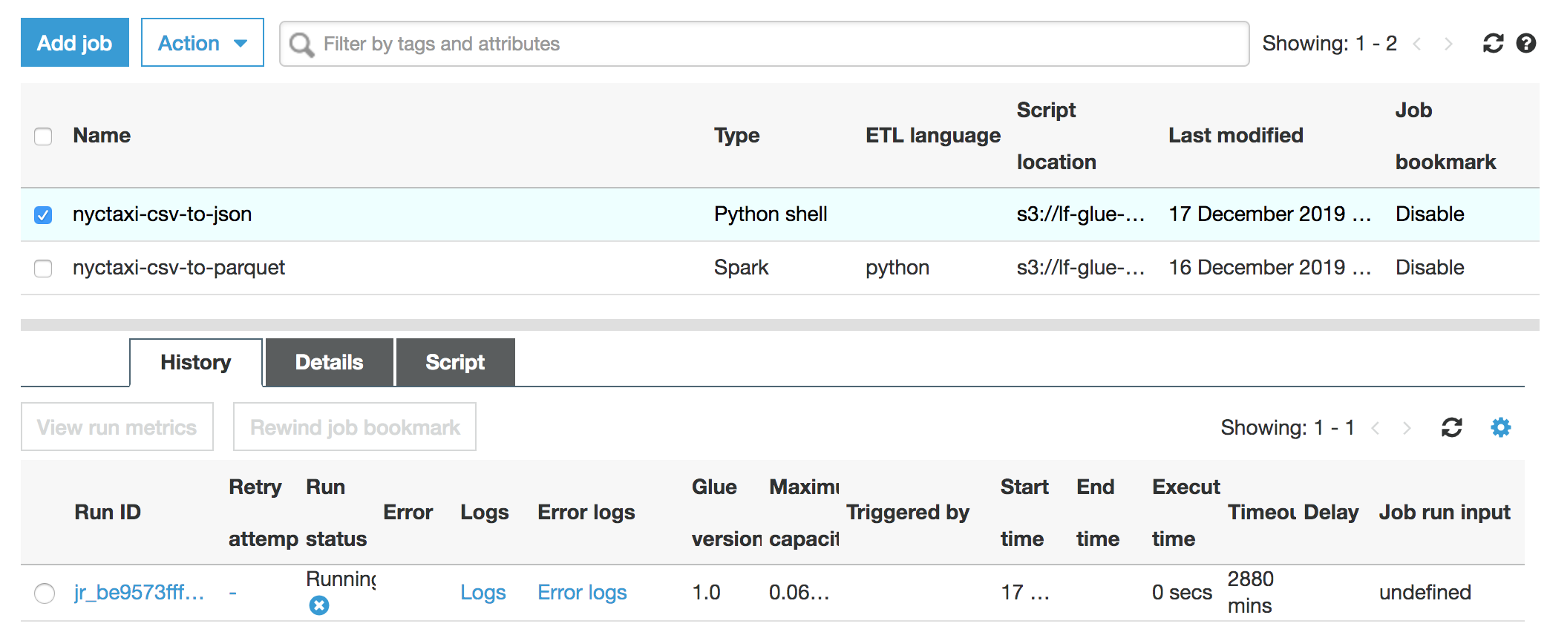](https://lakeformation.workshop.aws/images/pythonjob7.png)[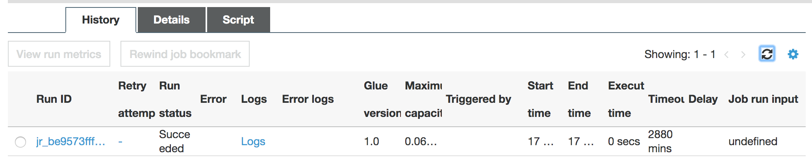](https://lakeformation.workshop.aws/images/pythonjob8.png)
8. A successful job will create a JSON file in the path where the input is stored. Go to your S3 console to verify the output file.[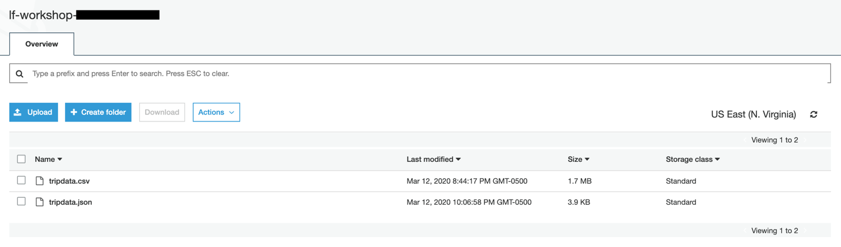](https://lakeformation.workshop.aws/images/pythonjob9.png)
9. You can download the JSON file and verify the content by opening it up in a text editor.[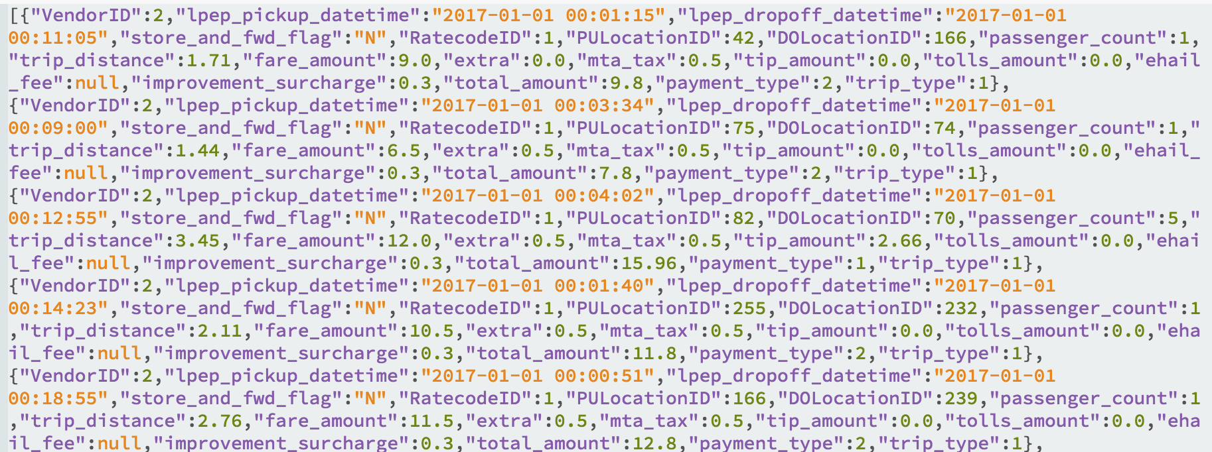](https://lakeformation.workshop.aws/images/pythonjob10.png)
10. By running the last two exercises, now you should have an understanding of Glue ETL, how to create a different type of Glue jobs, configure and run them in a serverless manner.

# DEVELOPMENT ENDPOINT

You can use Glue Development Endpoint to iteratively develop and test your extract, transform, and load (ETL) scripts. You can create, edit, and delete development endpoints using the AWS Glue console or API. When you create a development endpoint, you provide configuration values to provision the development environment. These values tell AWS Glue how to set up the network so that you can access the endpoint securely and the endpoint can access your data stores.  
  
You can then create a notebook that connects to the endpoint, and use your notebook to the author and test your ETL script. When you're satisfied with the results of your development process, you can create an ETL job that runs your script. With this process, you can add functions and debug your scripts in an interactive manner.  
  
In this exercise, you will learn how to create Glue development endpoint and how to run or debug scripts there.

1. Go to Glue console and click on Dev endpoints from the left and then click on Add endpoint[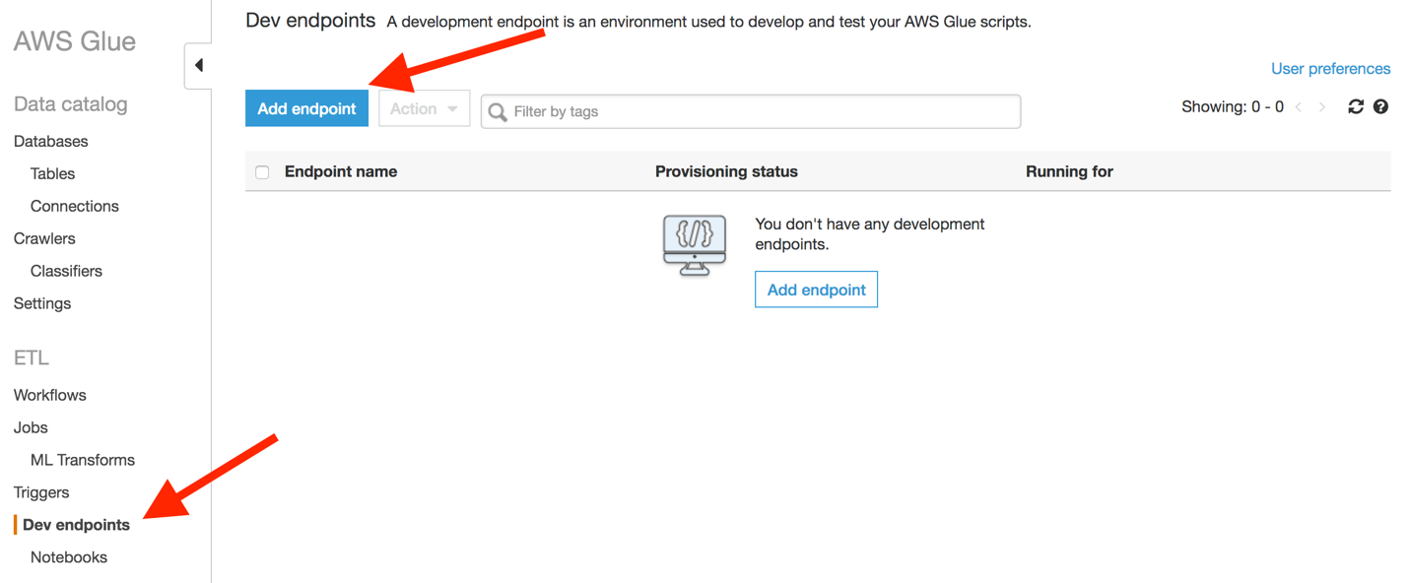](https://lakeformation.workshop.aws/images/devend1.png)
2. Give a name to your Glue endpoint glue-dev and select the same IAM role that you used in other exercises and click Next.[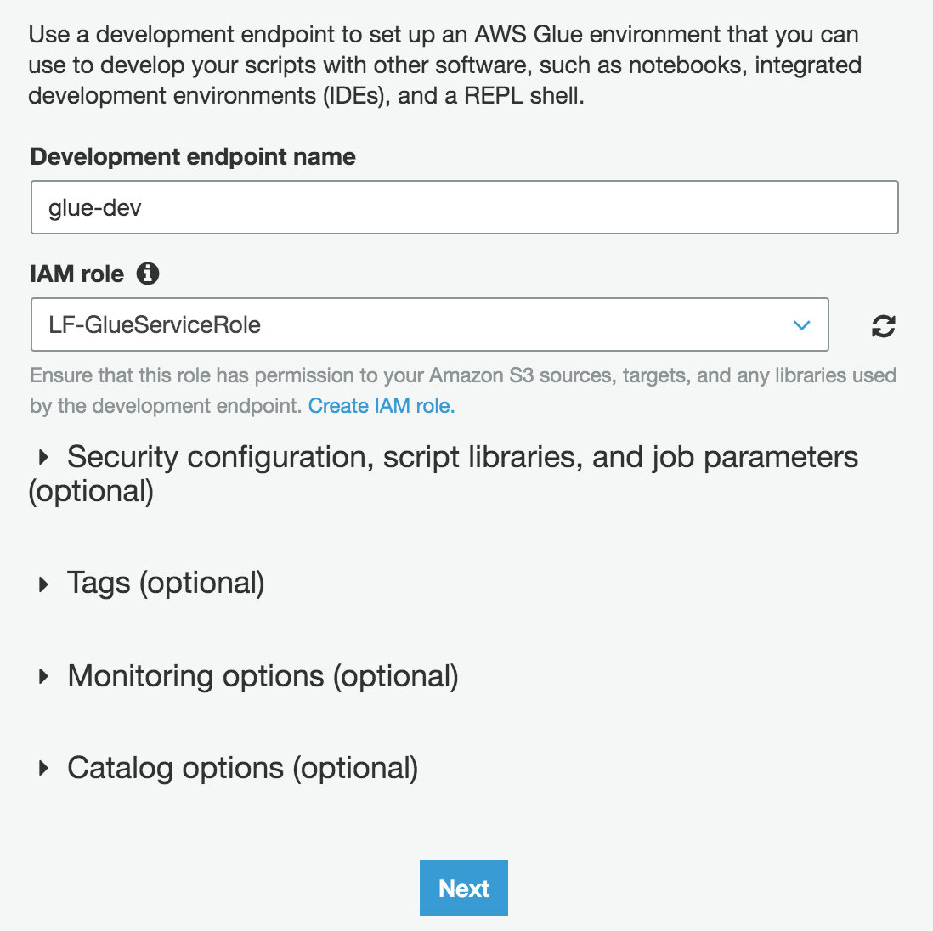](https://lakeformation.workshop.aws/images/devend2.png)
3. In this section, you provide your network configuration for the Glue endpoint. You already provided network configuration while creating Glue connection, you are going to use it. The Glue will capture the configuration from the connection and will towards your endpoint. Once you select mysql-connector, click Next to proceed.[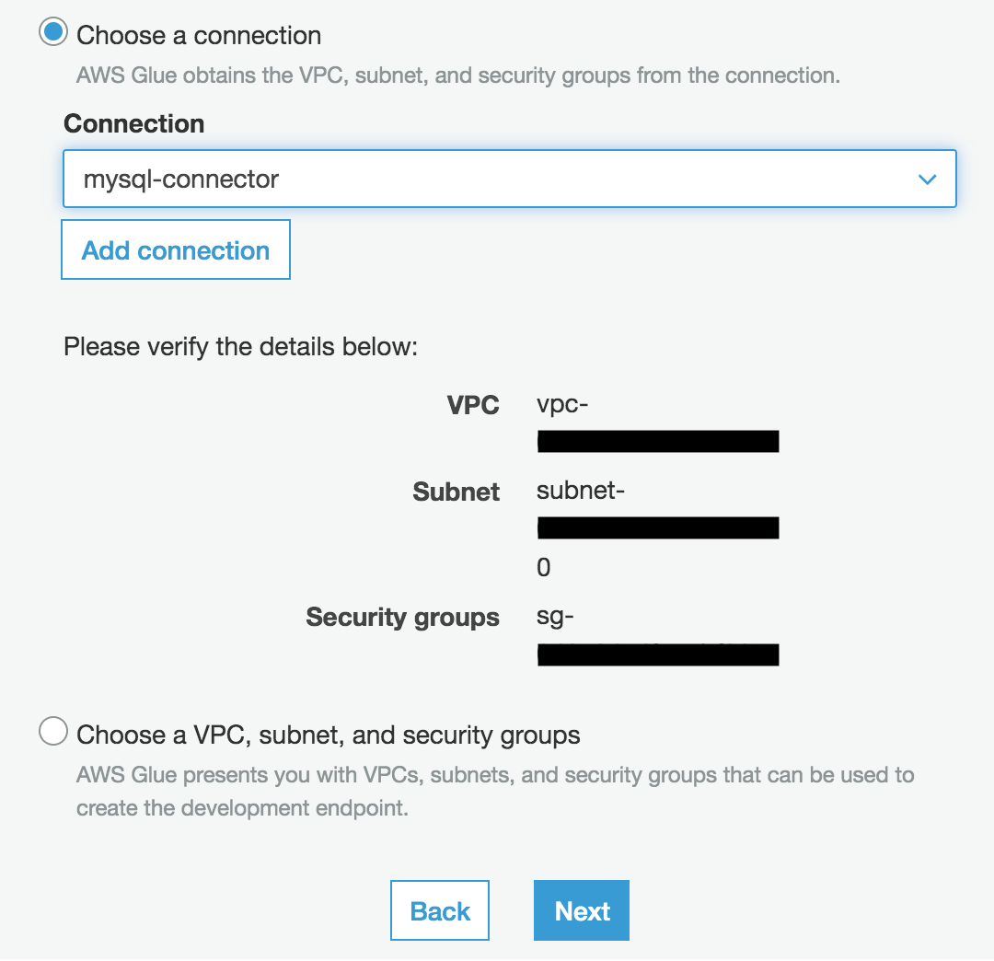](https://lakeformation.workshop.aws/images/devend3.png)
4. This section is optional. Sometimes, you may want to connect to the notebook from your laptop or local notebook client, in that case, you provide a public key, based on that public key, you get access to the remote notebook instance. Leave this option and proceed next.

[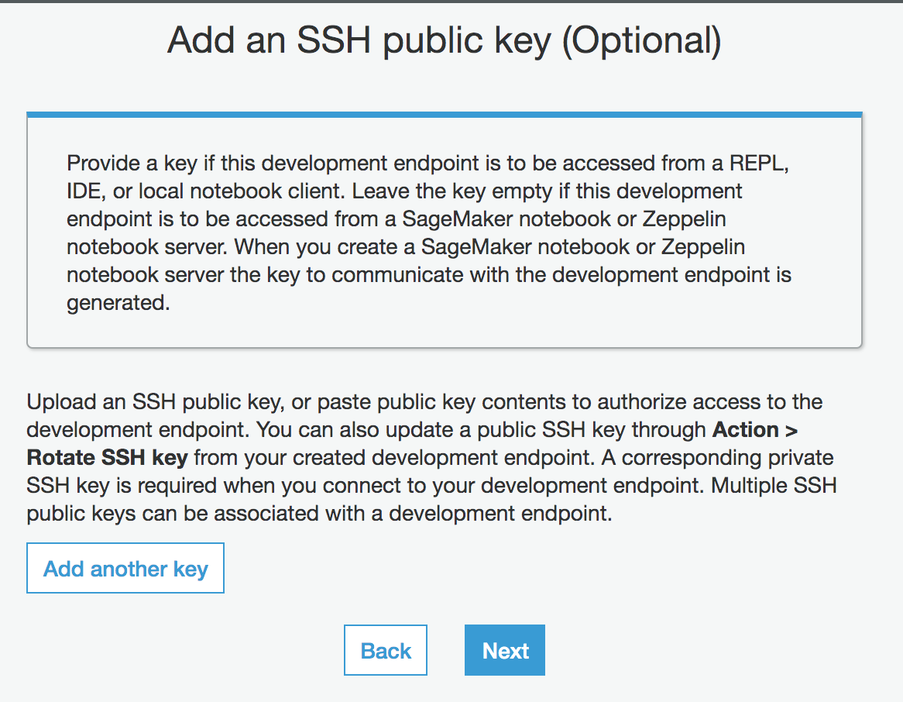](https://lakeformation.workshop.aws/images/devend4.png)

1. Review all your configuration and click Finish to create your Glue development endpoint.[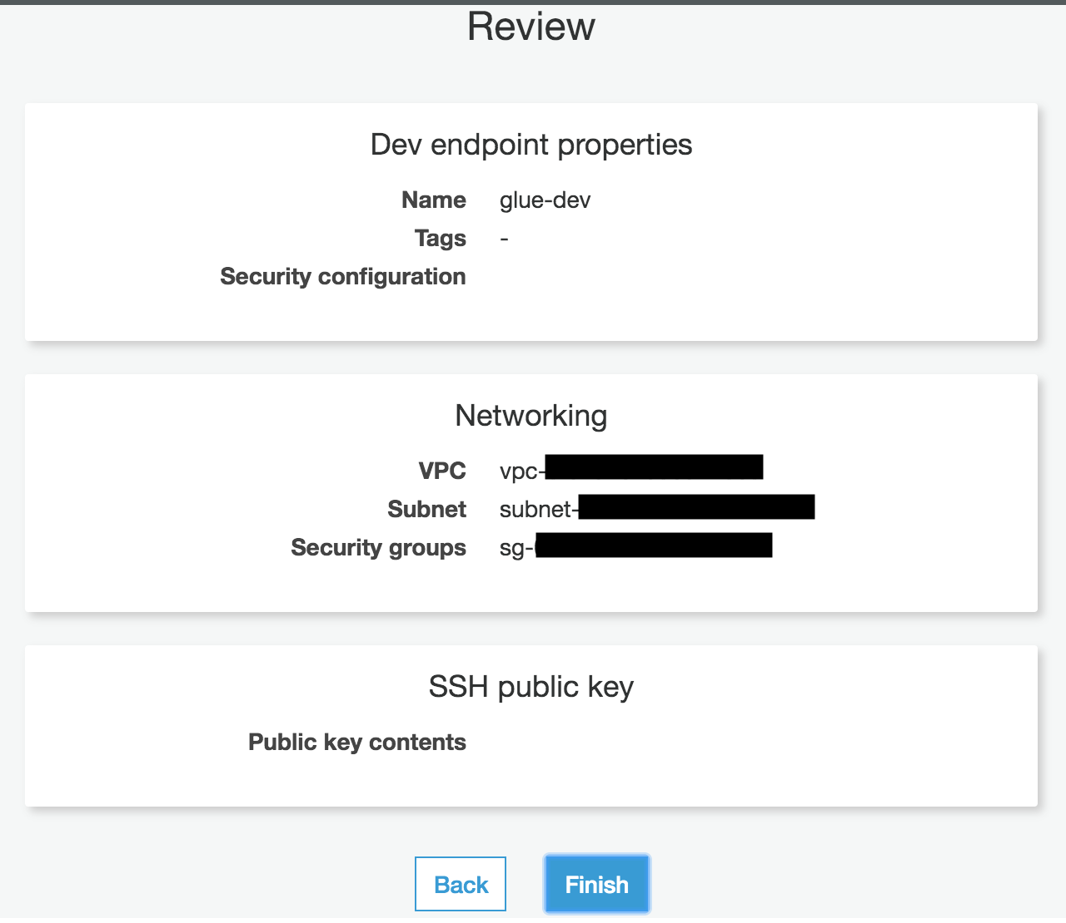](https://lakeformation.workshop.aws/images/devend5.png)
2. Glue endpoint creation process may take 4-8 minutes, you will see the status on the Glue endpoint console.[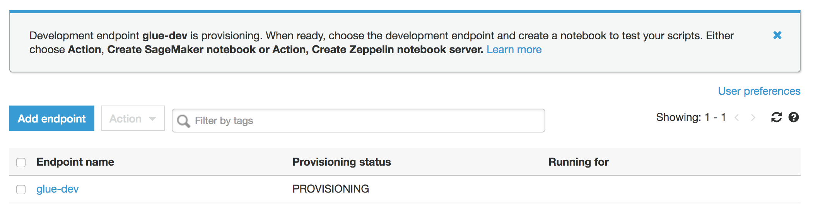](https://lakeformation.workshop.aws/images/devend6.png)
3. Once it's completed, the status will change to READY.[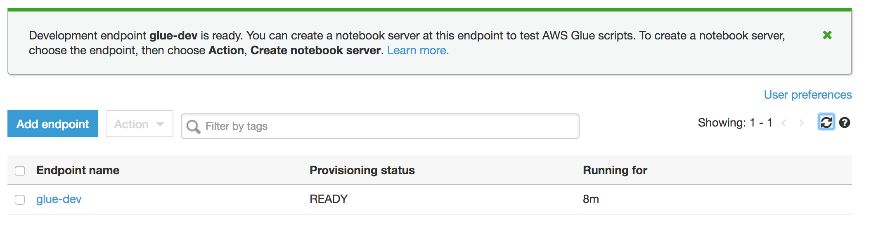](https://lakeformation.workshop.aws/images/devend7.png)
4. Now development endpoint is ready, you need an interface and interpreter to communicate and run your code. For that, you have two options - (a) Zeppelin notebook, and (b) SageMaker notebook. For this exercise, you will use SageMaker notebook. Click the development endpoint and select Create SageMaker notebook from the Action dropdown.[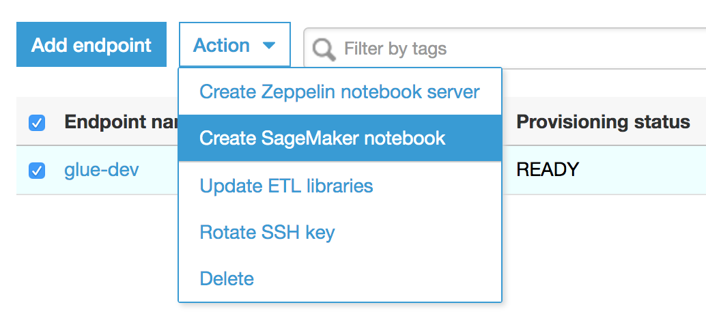](https://lakeformation.workshop.aws/images/devend8.png)
5. Now configure your notebook, give a name for your notebook and create a new IAM role for this notebook.[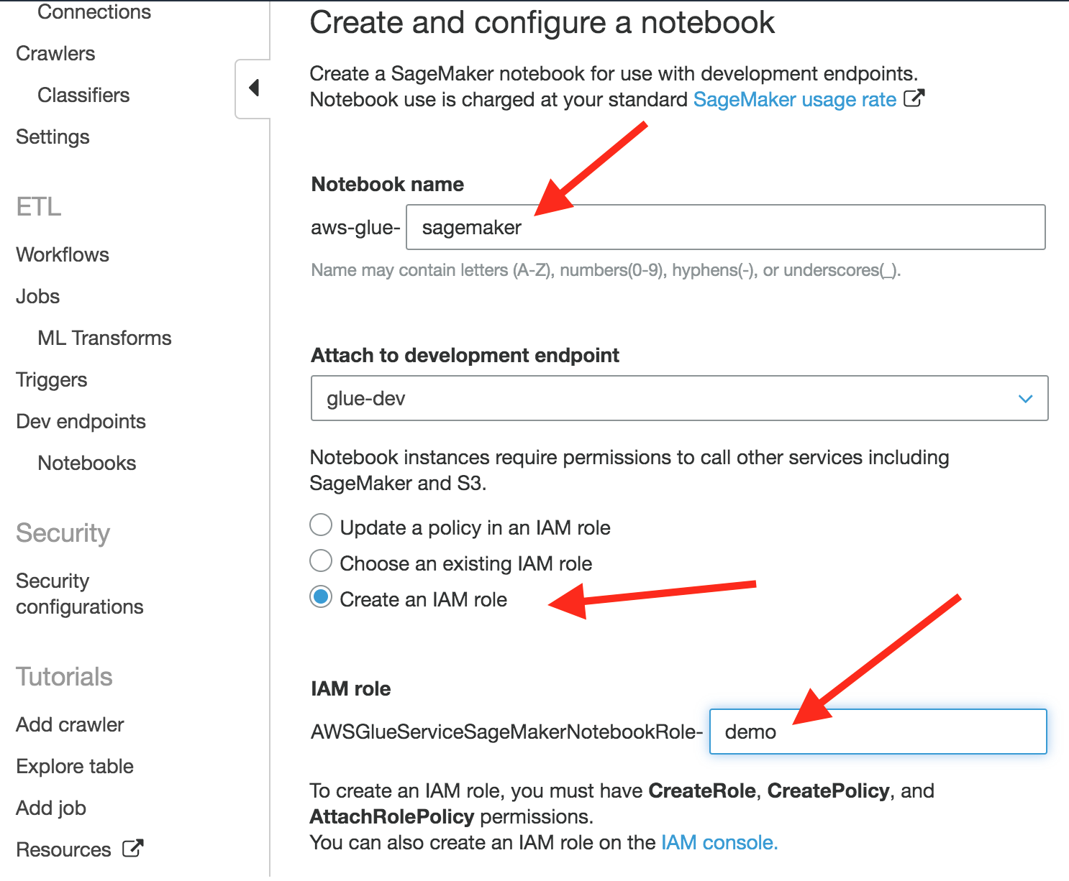](https://lakeformation.workshop.aws/images/devend9.png)
6. Glue will automatically pick up the rest of the configuration from your Glue endpoint. Leave the rest of the options unchanged and click on Create notebook.[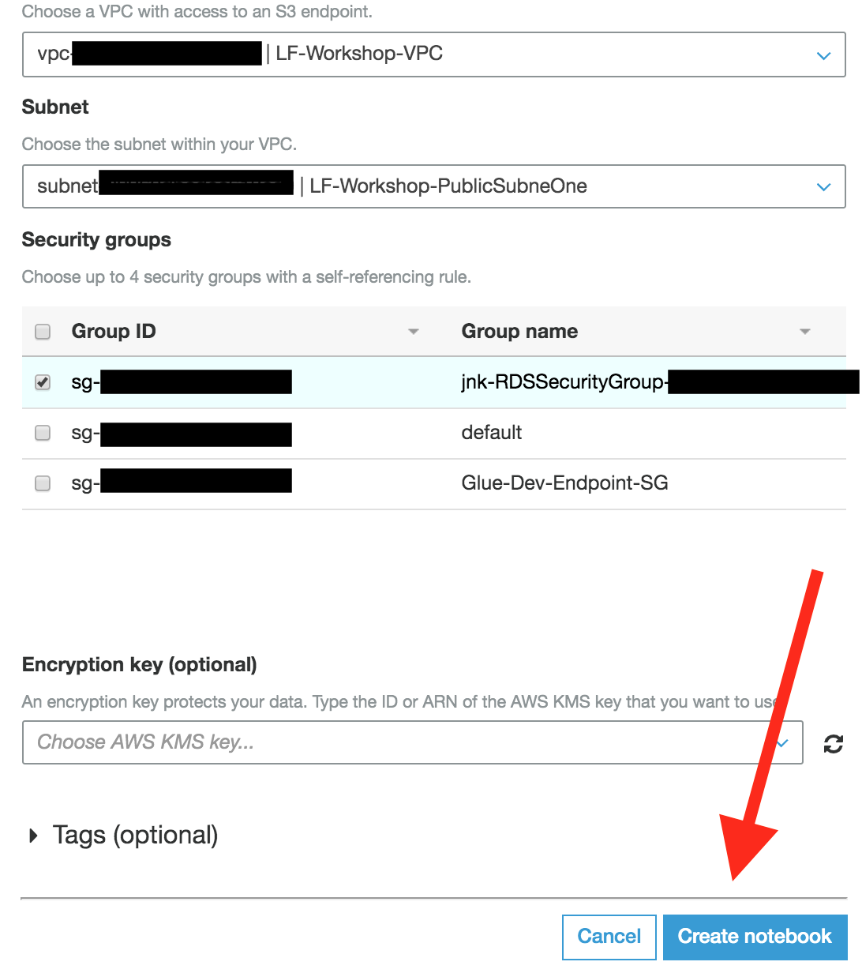](https://lakeformation.workshop.aws/images/devend10.png)
7. It will take a few minutes to start the SageMaker notebook. Once it's ready, the status will change from Starting to Running. Once it's ready, select the notebook instance from the list and click on Open notebook.[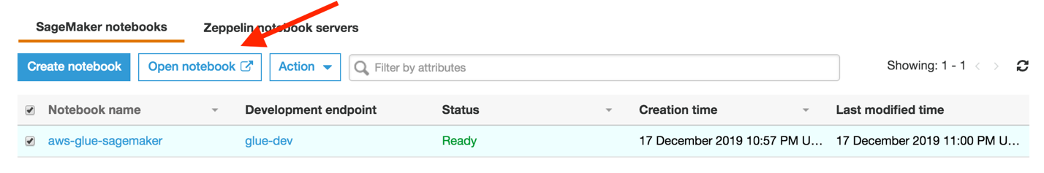](https://lakeformation.workshop.aws/images/devend11.png)
8. The default SageMaker notebook comes with a few Glue Examples. In this exercise, you will create a new notebook to explore the data that you crawled in the previous exercise.[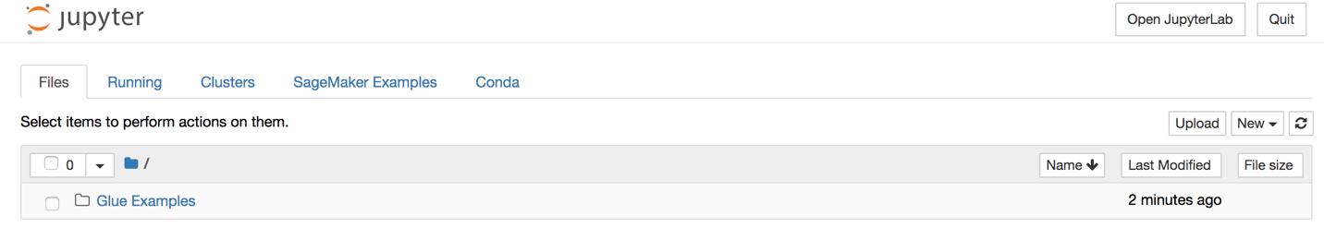](https://lakeformation.workshop.aws/images/devend12.png)
9. Click New on the right corner and select Sparkmagic (PySpark). It will open a new notebook, give a name for your notebook.[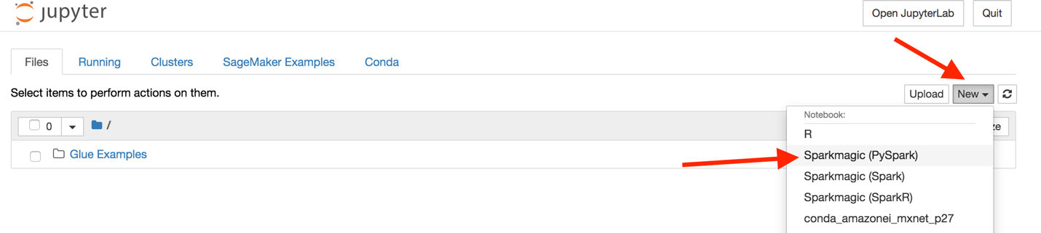](https://lakeformation.workshop.aws/images/devend13.png)
10. In the new notebook, you will create two sections - section (1) will initialize Spark and Glue context and section (2) to query NYC taxi data using an existing catalog.[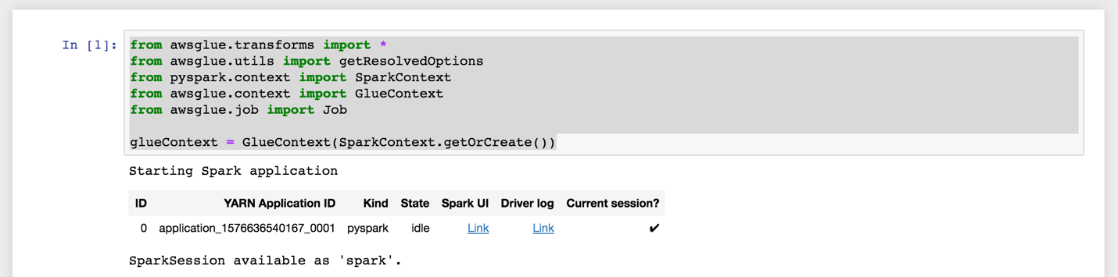](https://lakeformation.workshop.aws/images/devend14.png)[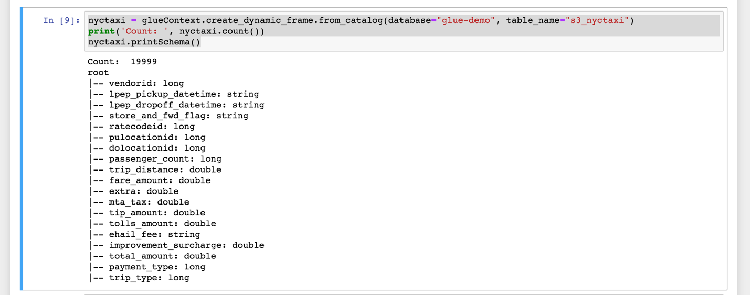](https://lakeformation.workshop.aws/images/devend15.png)
11. You can download the above sample script from the following attachment section.
12. By running a few PySpark blocks, now you learn how to use Glue endpoint to develop your Glue ETL scripts and debug them interactively.

 Attachments

• [glue-sample-script.txt](https://lakeformation.workshop.aws/glue-basics/glue-etl/dev-endpoints.files/glue-sample-script.txt) (0 kb)